Electronic Environmental Drinking Water Reporting (E2-DWR) System

WATER SYSTEMS User Guide
for
dlqor rEPORT

Texas Commission on Environmental Quality
(TCEQ)

Version: 2.5

June 23, 2015

Table of Contents
1 Introduction 3
1.1 State of Texas Environmental Electronic Reporting System (STEERS) 3
1.2 Electronic Environmental Reporting and the E2 System 3
1.3 Reasons for and Benefits of Electronic Reporting with E2 4
1.4 E2 Contact Information 4
1.5 E2 System Overview 4
2 Minimum System Requirements 6
3 E2-DWR System Description 7
3.1 Abbreviated eDWR Submission Process for Public Water System: 7
4 Getting Started 8
4.1 Creating a STEERS User Profile 8
5 E2-eDWR Online Data Entry Form 18
5.1 Online Data Entry Form for Disinfectant Level Quarterly Operating Report (DLQOR) 18

Introduction

State of Texas Environmental Electronic Reporting System (STEERS)
STEERS provides a platform to the public for on-line access to the Electronic Environmental (E2) Reporting System plus several other regulatory programing areas of the TCEQ. An individual obtains a free STEERS account with which they have on-line access to add, update, renew and modify their accounts for a number of regulatory programs. STEERS enables secure submission of electronic data which satisfies EPA CROss Media Electronic Reporting Rule (CROMERR) requirements.
Individuals that have an issue with STEERS have access to telephone or e-mail assistance from the STEERS team. The STEERS team provides telephone support to the public for help with the STEERS program only. Any issues the individual has with a regulatory program are referred to the program area for assistance. STEERS staff also has access to the Internal Data Application (IDA) to re-set passwords for users whose accounts are locked.

STEERS Contact
State of Texas Environmental Electronic Reporting System (STEERS)
Texas Commission on Environmental Quality (TCEQ)
STEERS Help line
STEERS (MC 226)
E-mail: STEERS@tceq.texas.gov
Phone: (512) 239-6925

Electronic Environmental Reporting and the E2 System
The Electronic Environmental (E2) Reporting System is a web-based application that allows the regulated community to electronically submit reports to the Texas Commission on Environmental Quality (TCEQ). The E2 system provides an alternative to submitting hand-written or paper-based reports that is faster, more efficient, and requires less processing for water systems and TCEQ. As a fully operational electronic reporting system, all of the necessary legal, security, and electronic signature functionalities have been included to serve as a completely paperless reporting system.

The E2 system allows public water systems (PWS) to submit the following reports:
- Disinfectant Level Quarterly Operating Report (DLQOR)

Reasons for and Benefits of Electronic Reporting with E2
Electronic reporting provides the following benefits:

- Gives the user greater control over the quality of data flow
- Provides greater assurance of receipt of required regulatory reporting documents
- Reduces reporting costs by offering a streamlined reporting method using readily available computer tools
- Offers on-line availability of reports and their processing status
- Improves reported data integrity and security
- Saves the TCEQ costs by reducing, and better utilizing resources required for managing reports
- Adds to the overall effectiveness of the TCEQ program areas with faster response for data analyses, compliance assessment, and decision-making

E2 Contact Information
If you need help entering data, checking on your status/receipt of your data, etc, please contact the TCEQ Main Line and ask for a specific Program Coordinator.

- DLQOR Coordinator

The Program Coordinators can be reached at:

DWR
Program Coordinator
Public Drinking Water Section (MC-155)
Water Supply Division
Texas Commission on Environmental Quality (TCEQ)
ESubdata@tceq.texas.gov
Phone: (512) 239-4691

All questions regarding login issues, technical problems, forgotten passwords, or setting up your STEERS account should be directed to the STEERS Help Line.

E2 System Overview
As a web-enabled system, the E2 system provides Water Systems with the following capabilities with respect to Water System Reports:

- Ability to submit original or revised water system reports. E2 allows water systems to either fill out the reports onlineor copy-and-paste reports from a water system’s local data system.
- Ability to view validation messages online. All submissions can be validated to verify that they meet minimum criteria.
- Ability to save partially completed reports. If a user does not finish filling out a report in one session, he or she can save the report and resume filling it out at a later time. TCEQ will not review partially completed reports. The user must submit the report in order for the data to be processed by TCEQ.
- Ability to view and print previously submitted reports. All submissions made through the E2 reporting system are saved for later retrieval.
- Ability to monitor the status of all submissions. Users can log in to see the current processing status of all submissions (Pending, Processed, and Rejected). Users also receive an email notification of the submission status.
In essence, the E2 system serves as an electronic filing cabinet, allowing Public Water Systems (PWS) to manage their own reporting to TCEQ and monitor the status of submitted reports.

In order to provide sufficient security for all submitted information, access to the E2 system is restricted in the following ways:

- Any person who wants to have access to the E2 system must have an authorized STEERS User Account.
- Any person who wants to submit reports for a particular Water System must be granted an association with their Water System.
- In order to submit the reports online in E2, the STEERS user account must have the "PDW System Sign and Submit" role.
- Any person who wishes to certify water system reports must fill out an STEERS Participation Agreement (SPA), and submit it to the TCEQ online or via mail.

Minimum System Requirements
Water Systems must be able to access TCEQ’s E2 website through the Internet. Typically, such access is available either through a dedicated connection (i.e. local area network) or a modem connection to an Internet Service Provider.

To ensure that all of the features of the E2 system are available, Water Systems must use Microsoft Internet Explorer web browser (version 7.0 or higher) or Firefox (version 10.0 or higher). The performance of the E2 system will vary based on the computer’s internet connection speed, CPU, operating system, and available memory. The minimum system configuration recommendation is as follows:
- Broadband Internet Connection or higher
- Pentium II processor or higher
- VGA or higher resolution monitor (at least 800 x 600 resolution)
- Microsoft Windows XP or higher
- 256 MB of RAM or higher
- Web Browser:
  - Designed for Microsoft Internet Explorer 9.0
  - Also works on other browsers
    - Microsoft Internet Explorer 7.0 or higher
    - Google Chrome
    - Mozilla Firefox
  - Safari web browser was not tested and will most likely not work with the E2 interface
- PDF Reader for viewing of PDF files
- Printer for printing submission in report format and/or Copy of Record
- Email account

E2-DWR System Description

This section provides a brief overview of the report submission process in E2.

Abbreviated eDWR Submission Process for Public Water System:

Step 1: Via STEERS, Water System User logs into the E2 Reporting System via the Internet with user ID, password, and an answer to a security question.
Step 2: Using the Water System tab Create New Reports screen, the user selects a water system from the drop down menu to complete the following reports:
- Disinfectant Level Quarterly Operating Report (DLQOR)
Step 3: The user prepares Water System report in accordance with reporting requirements, as specified using any of the submission methods below:
- Step 3A: Online Data Entry for DLQOR
Step 4: Enter the STEERS password and certify the data entered.
Step 5: E2 receives the file, and issues a receipt of confirmation to the user on the screen. A separate receipt confirmation email will be automatically sent to the user. The E2 verifies that the submitted file conforms to the specific data validation rules and business requirements defined for each of the reporting forms.
Step 6: Valid submissions can be viewed and printed at any time.

Getting Started

Creating a STEERS User Profile
In order to gain access to the E2 Reporting System, a State of Texas Environmental Electronic Reporting System (STEERS) user account at https://www3.tceq.texas.gov/steers/index.cfm must first be created.

From the above URL, press the “to create a new account” button to create a new STEERS user account.

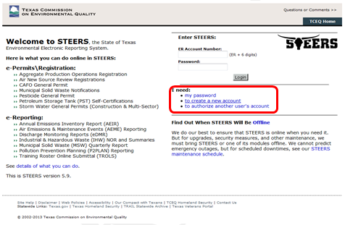
To create a new STEERS user account, follow the instructions and press the “Create New Account” button to begin. Pressing on the “Create New Account” button will open the Applicant Information screen.
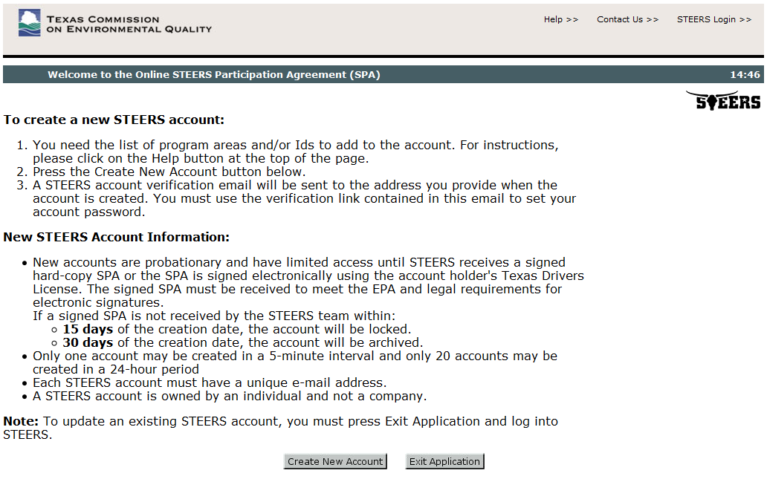
Enter the required user information as indicated by a red asterisk. After entering the user information, scroll to the bottom of the screen and press the “Next” button.

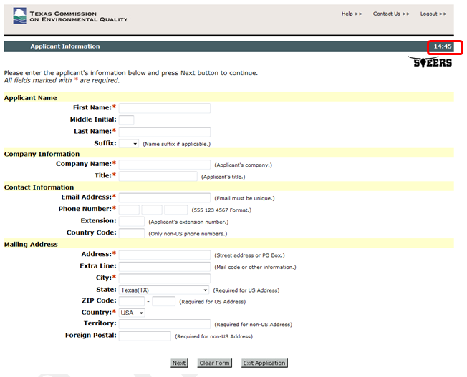

Please note the timer in the corner; you have 15 minutes to fill out each page before the system will automatically log you out. Make sure you have all the information required to fill out each form.
The “Review Applicant Data” page will be displayed. Press the “Next” to continue.

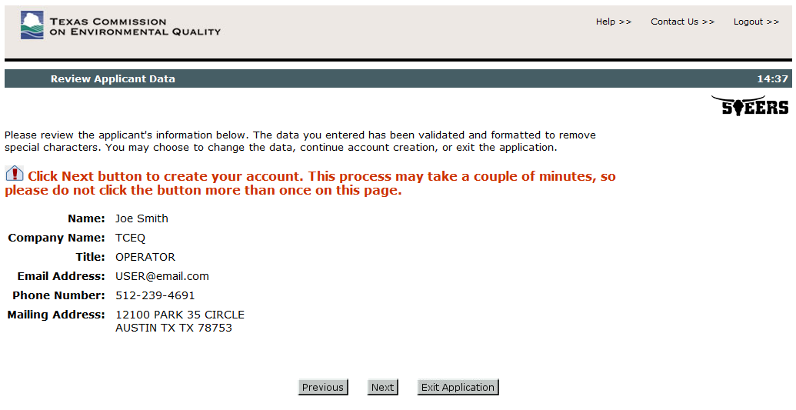

On the “STEERS Account Security Question Update” page, select 5 security questions and provide the desired answers accordingly. Press the “Save” button to continue.

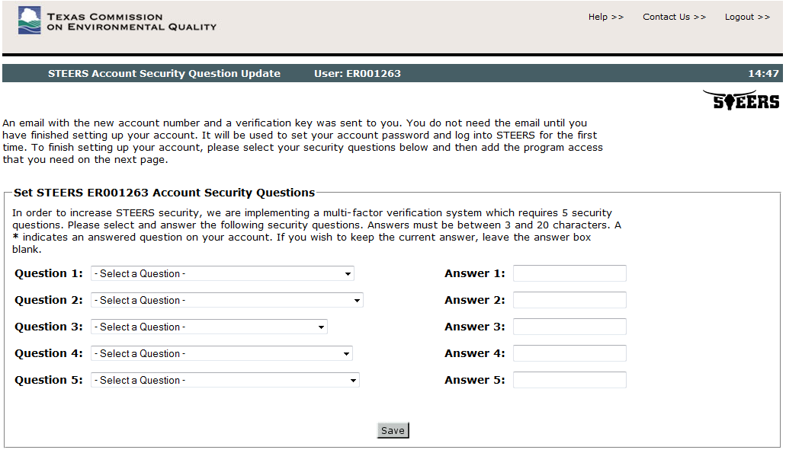

Next, select the desired STEERS program for the selected user account as follows:

- Public Drinking Water - Systems (PDWSYS)

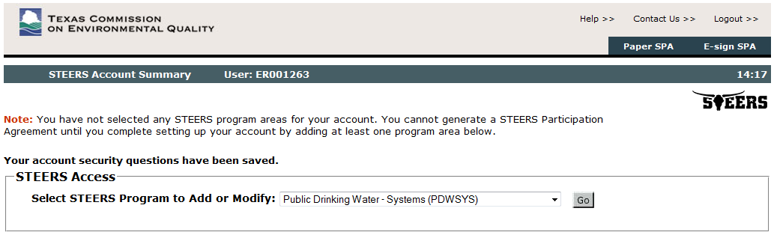

Please select the applicable “Access Type”
- PDW System Read - view only
- PDW System Edit - view, create, delete, and modify
- PDW System Sign and Submit - view, create, delete, modify, sign, and submit
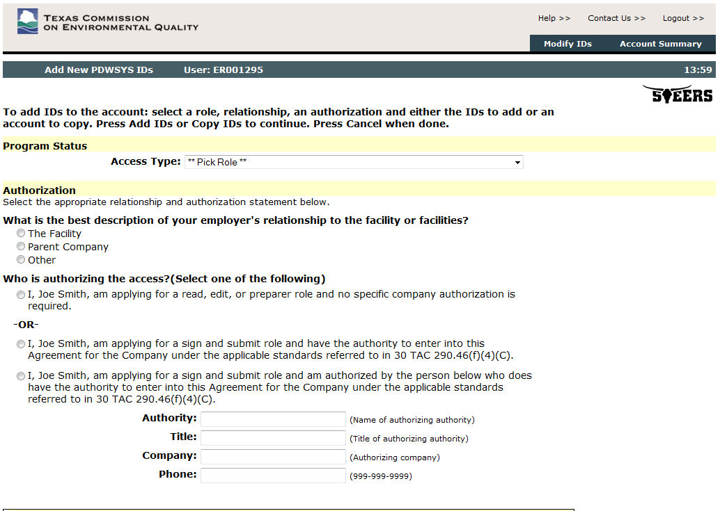
After selecting the Access Type, you must choose an Authorization Type as well. According to 30 TAC 290.46(f)(4)(C) reports must be signed by a licensed water works operator. The applicable standards that applied to signing the paper DLQOR also apply to electronic submittals (30 TAC 19.12(c)).
There are three options for Authorization:
- I am applying and no specific company authorization is required
  - If you chose Access Types “System Read” or “System Edit”, you can choose this option.

- I am applying for a sign and submit role and have the authority…
- If you chose Access Type Sign and Submit, you can choose this option or option 3.

- I am applying for a sign and submit role and am authorized by the person below…
  - If you chose Access Type Sign and Submit, you can choose this option or option 2.
  - Please enter in the information of the Authorizing Company.

Once you have determined your Access and Authorization levels, you can enter your PDW System ID. Enter the PDW System ID(s) as follows:

- Public Drinking Water - Systems (PDWSYS) Public Water System ID
Once “Access Type”, “Authorization Type”, and “PDW System ID” are selected/entered, press the “Add IDs” button to continue.
- ID must be entered in the format TX1234567. If you receive an error stating the ID number is not recognized or is associated with another account, make sure you have added the TX to your PWS ID number.
- You can also Copy IDs from another account using the STEERS account ER number of another STEERS user.
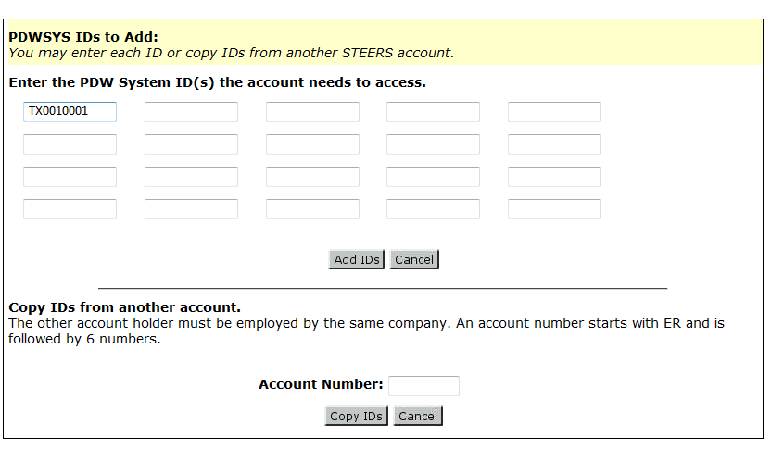

On the confirmation/review page, press the “Confirm Add” button to save your selection

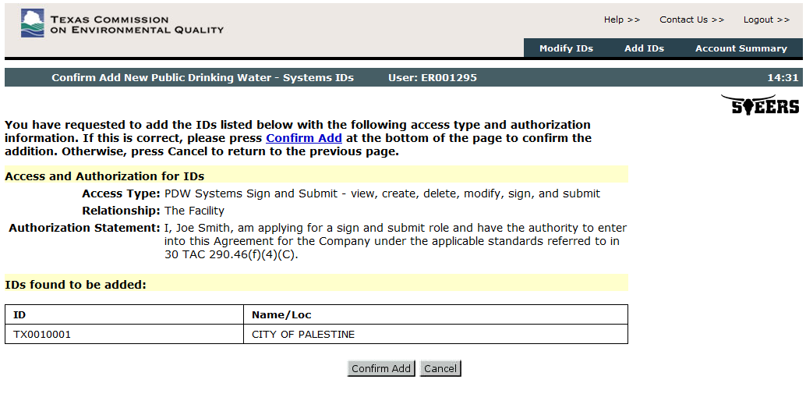

Please note that new STEERS user accounts will receive a “probation” status until the STEERS Participation Agreement (SPA) is received by the TCEQ (either by mail or electronically).
Please write down or take note of your User ID (ex ER001263), this ID will be required to log into your STEERS/E2 account from now on. An email with this ID has also been sent to you.

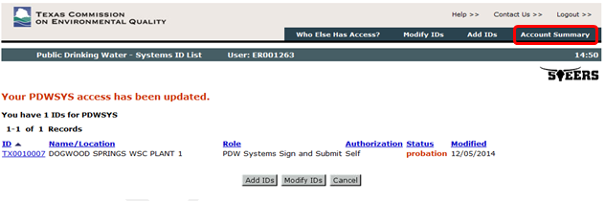

To access the STEERS Participation Agreement (SPA), press the “Account Summary” button on the top of the page. Once the STEERS Account Summary page is opened, the options for SPA are made available as follows:

- Mail “Paper SPA” For mailing of SPA, press the “Paper SPA” button to access STEERS Participation Agreement (SPA).
- Electronic “E-Sign SPA” (via Texas Driver’s License). For online, electronically signed SPA, press the “e-sign SPA” button to access the STEERS Participation Agreement – E-sign page. Use your Texas Driver’s License information to electronically sign SPA online.

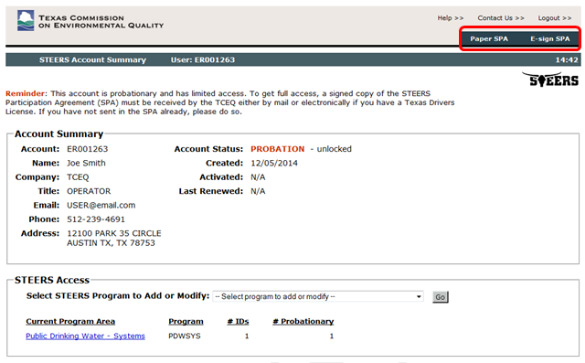

Click on either “Paper SPA” or “E-sign SPA”.

- To submit via mail, click the Paper SPA button. Then press the “Generate Your SPA” to create the SPA printout for the mailing to TCEQ.
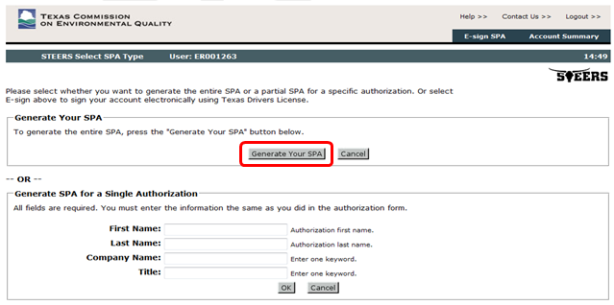

Print (using your browser’s print button), sign, and mail form to the STEERS address on the top of the form.
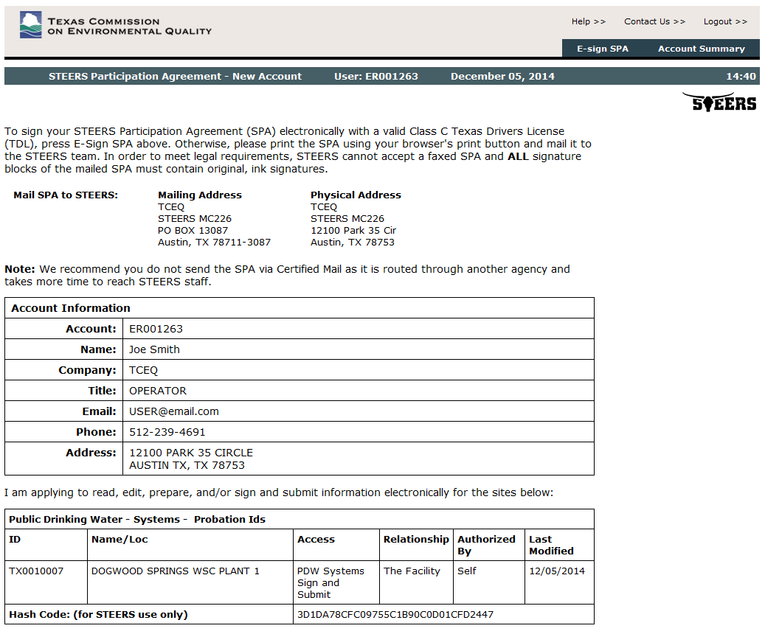
- For online electronically signed SPA, press the “e-Sign SPA” button to access STEERS Participation Agreement - E-sign page. Read through the information and then scroll to the bottom of the page. Use your Texas Driver’s License information to electronically sign SPA online. Be sure to check both boxes just above the e-sign button.

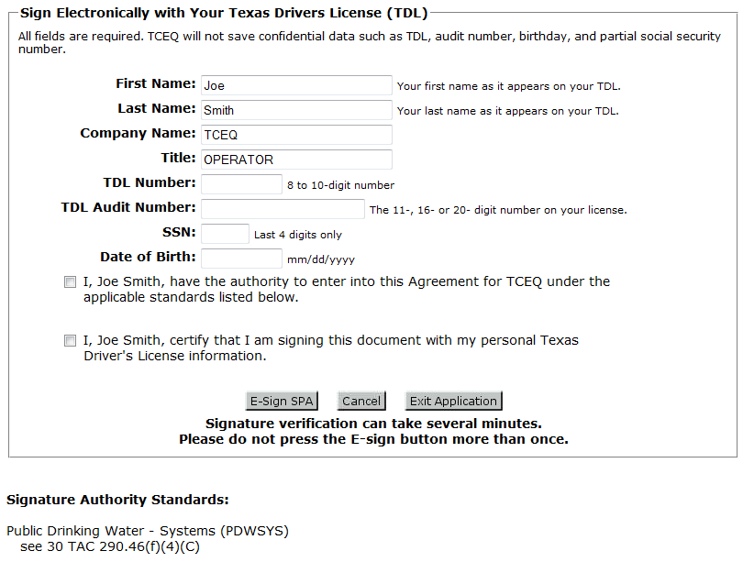

Once you have either electronically submitted or printed out your SPA, you may exit out of the application. You have now completed the creation your STEERS account. You will now be able to sign into E2 without going through this process again.

You will receive an email stating that you have created a STEERS account and prompting you to create a password for E2. Follow the steps outlined in the email to create your password. Make sure to write down your Login ID (ex. ER001263) and Password and keep them in a secure location. You will need your Login ID and Password to access E2 and submit electronic forms.

E2-eDWR Online Data Entry Form
The online data entry forms currently available in TCEQ’s E2 Reporting System are described in the section below.

- Disinfectant Level Quarterly Operating Report (DLQOR)

Please note that after 20 minutes of inactivity, you will be signed out of E2. Make sure to regularly save your progress.

Online Data Entry Form for Disinfectant Level Quarterly Operating Report (DLQOR)
The data entry process flow for the “Disinfectant Level Quarterly Operating Report (DLQOR)” online data entry form is as follows. Please read through each step carefully.

Step 1A: Login to STEERS with a valid user account number and password

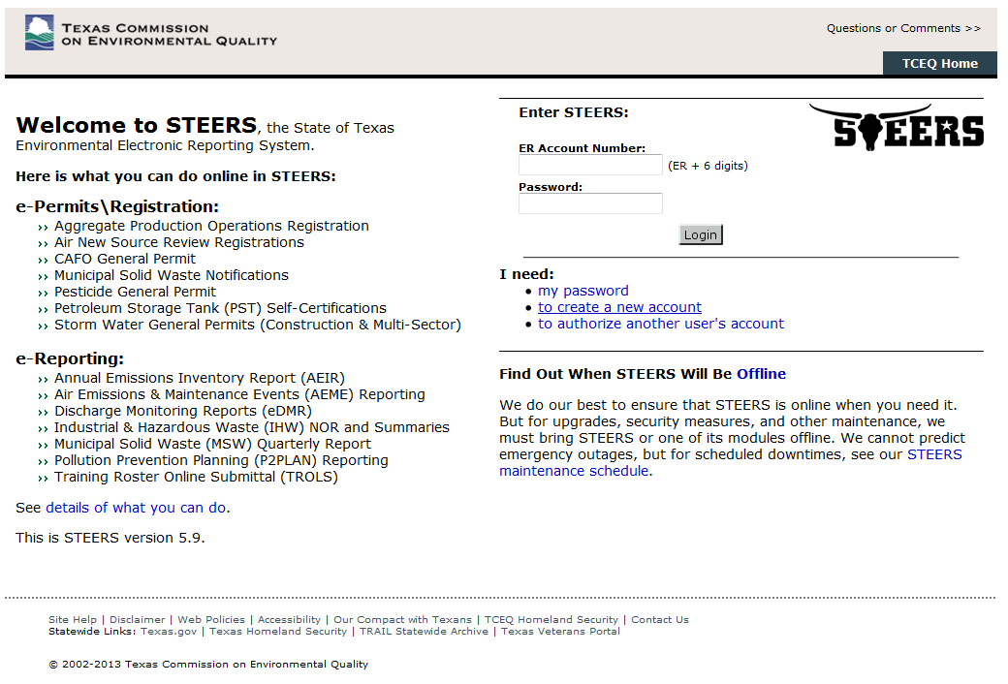

Step 1B: Once logged into STEERS, select the Public Drinking Water Systems (PDWSYS) Program module menu option to access the E2 Reporting System
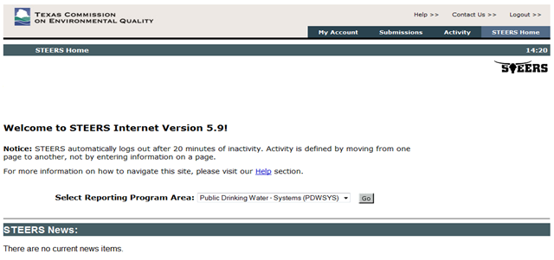

Step 2: After E2 validates the user account via STEERS web services, the PWS User is presented with the E2 Home page. Click on the Water System tab.

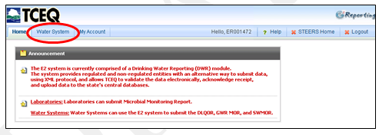

Step 3: For the PWS User, the Water System Reporting Module menu option is available as follows:
- Create New Reports
- Upload SWMOR Reports (This option is not yet functional. SWMORs cannot be submitted electronically at this time)
- Retrieved Saved Reports
- View Submissions
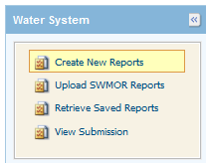
Step 4: From the Water System Reporting Module, press “Create New Reports” menu option.

Step 5: Select a Water System from the dropdown “associated” PWS list and press the “Online Data Entry” icon to begin online data entry form for Disinfectant Level Quarterly Operating Report (DLQOR).
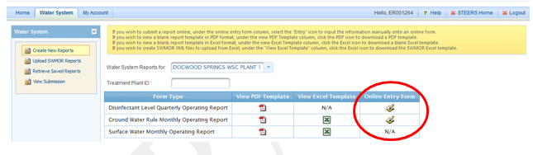

Please note that on the “Create New Report” page for the Water System Reporting Module, the following options are also available:

- View PDF Template present a “blank” PDF form of DLQOR. Choosing this option will not electronically submit the DLQOR. This is merely a blank PDF that can be printed out or viewed for reference.
Step 6: Once the “Online Data Entry” link is pressed, a pop up window will be displayed as shown below. To proceed, press the “OK” button. This will open the Disinfectant Level Quarterly Operating Report (DLQOR) for the user to begin adding information.
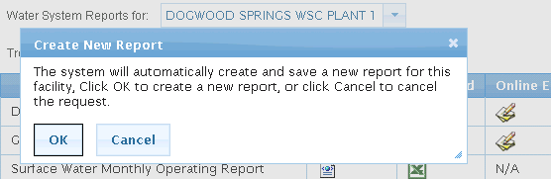

Step 7: On the DLQOR Online Data Entry Form for the selected PWS (in step #5), the following info will be displayed on screen:
      - Public Water System ID
      - Public Water System Name

These fields are read-only and locked from editing. 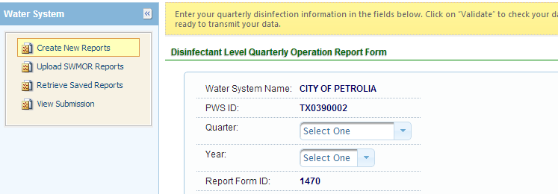
Just like on the paper form, select the Quarter, Year, and Residual Type, then fill in the DLQOR form with the required disinfectant residual information. An example online data entry form for DLQOR is shown below:
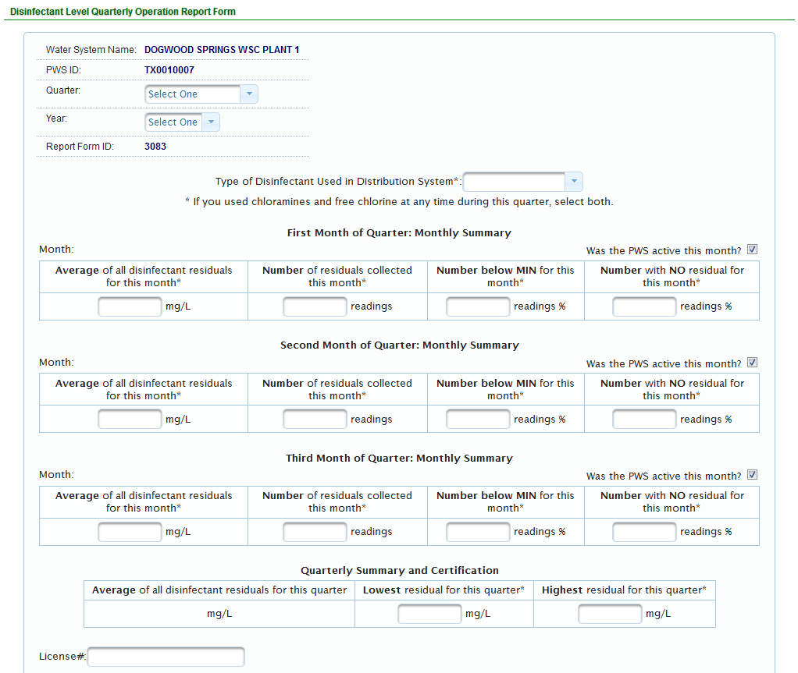
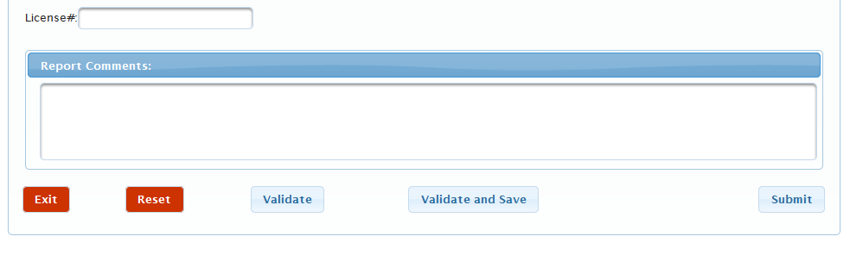

Every data field on the data entry form (except “report comments”) is required for online submission.

Note: At any point during the data entry the user can press the “Validate” button to check that the information entered against the QA/QC data validations defined for DLQOR. At any time the user may save the values that have been entered on the DLQOR online entry form and return at a later time by pressing the “Exit” button.

Once the user has completed adding the data and the form is complete, the “Validate and Save” button must be pressed. This checks that the data is valid and saves the record to the report.

Step 8: When the “Validate” or “Validate and Save” buttons are pressed, the following QA/QC data validations will run.

On the online data entry form, the validation logic in First / Second / Third Month Summary Result is as follows
      - Year starts from 2008
      - The 4 quarters are defined as follows
        - 1st: Jan/Feb/Mar due on Apr 10
        - 2nd: Apr/May/Jun due on Jul 10
        - 3rd: Jul/Aug/Sep due on Oct 10
        - 4th: Oct/Nov/Dec due on Jan 10
      - “Inactive” for the selected month will disable data entry of summary result
      - If disinfectant residuals is > 4.0 mg/l, system will display a warning message (but allow user to submit)
      - Use one decimal point for average residual values
      - Use only whole numbers for number of residual samples
      - For “Active” Month, the number of residual samples should be greater than 0.
        - If 0 is entered, the system will issue a warning “Number of residuals collected is less than required by rule.”
      - Number of residuals below the minimum must be between the total number of residuals collected and the number of samples with no residuals.
      - Auto-calculate percent at “number below MIN” and “number with NO residual”. The calculated percent will be rounded to 1 decimal place (e.g. 25.7%).
On the online data entry form, the validation logic in Quarterly Summary and Certification Result are as follows
      - If all quarters are “Inactive”, data entry of Quarterly Summary result will be disabled.
      - Auto-calculate “weighted” Average Disinfectant and round to 2 decimal places (e.g. 2.75%)
      - If the reading for "the Number with NO residual" is greater than 0 for any month in the quarter, the “Lowest” disinfectant residual for this quarter must be 0.
      - If the reading for "the Number with NO residual" is 0 for any month in the quarter, the “Lowest” disinfectant residual for this quarter must be 0.
      - If the reading for “the Number with NO residual” is 0 for ALL of the months in the quarter, the “Lowest” disinfectant residuals for this quarter must be greater than 0.
      - The “Highest” disinfectant residual for this quarter cannot be less than any of the Average disinfectant residual values in the First / Second / Third Month.
      - Type of “disinfectant used” determines the warning for the minimum allowable value for “Lowest” disinfectant residuals as follows:
        - Chlorine Free: 0.2 mg/L
        - Total & Both: 0.5 mg/L
      - The warning for maximum allowable value for the “Highest” disinfectant residual is 4.0 mg/l.
Note: You may receive an error or warning message after you hit the Validate button. Please make sure all of your data is correct before you hit the submit button. Examples of the error/warning messages are shown below.

Validation failed messages point out an inconsistency in the data that must be fixed before the DLQOR can be submitted.
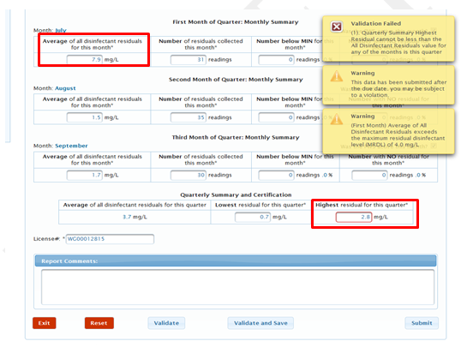
This error message occurred because the highest residual for the quarter cannot be less than the average of any single month. The data would need to be corrected before submittal.

Warning messages do not prevent you from submitting the DLQOR, they merely point out potential issues/violations.
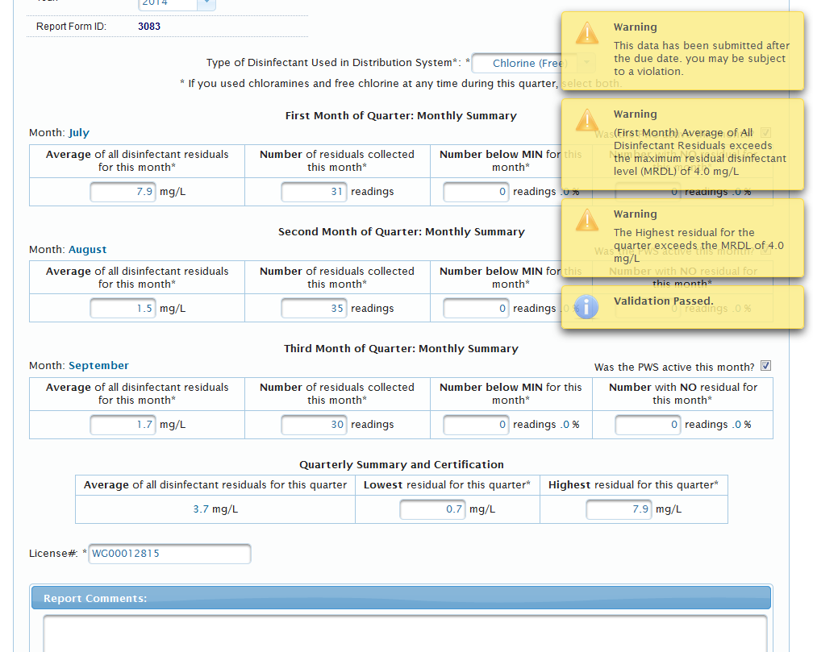
These warning messages do not indicate an error in data entry, only that the data entered may lead to a violation. No changes to the data would need to be made, and the form can be submitted as is.

If you have “Sign and Submit” access, move on to Step 9.

If you chose the “System Edit” access type, click the Validate and Save Button when you have finished filling out the form. You can review the forms you have saved under the “Retrieve Saved Reports” menu option.

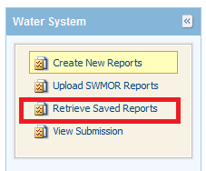

Choose the Water System from the drop-down menu you wish to review the reports of.
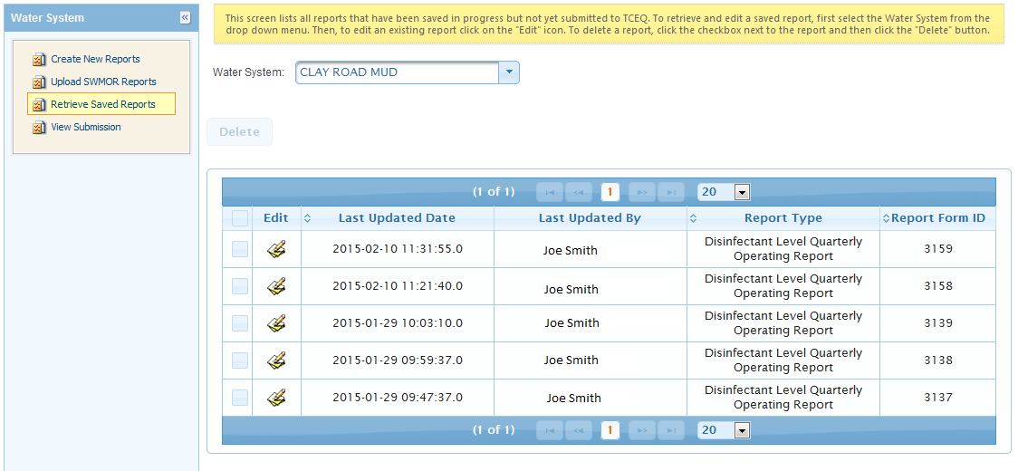

The authorized Sign and Submit user can access these reports and submit them through this same menu option.

If you are entering multiple DLQORs, once you have entered the information for one report, hit Validate and Save and then click the Exit button. This will return you to the main Water System Reporting Module, choose another PWS from the drop down menu and follow the same steps (Steps 3-8) for entering the DLQOR information.

Note: Saving reports is not the same as submitting them. You must follow the steps outlined below in order for your DLQOR to be submitted and received by TCEQ.

Step 9: When a PWS user is ready to submit the data entered on the DLQOR form, press the “Submit” button. Once pressed, a pop-up window will be displayed as shown below. To proceed, press the “Yes” button. This will open the submit page.

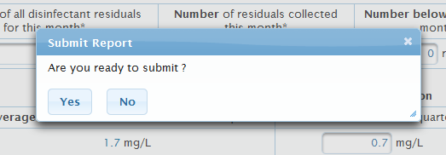

Please take steps to ensure that you do not submit multiple DLQORs for the same system. Duplicate entries can lead to errors in submittal. If you believe you have accidentally submitted the wrong information for a system, submit a corrected copy, but add a note in the Report Comments field stating “Revised Data” or “Correct Info.” The system will automatically accept the first submitted report as the correct data, adding a note will allow us to manually find the correct duplicate.

Step 10: On the E2 submission page, enter your password and place a check mark on the “I Certify” checkbox to submit the Disinfectant Level Quarterly Operating Report (DLQOR) report online. Press “Submit” to submit the report.
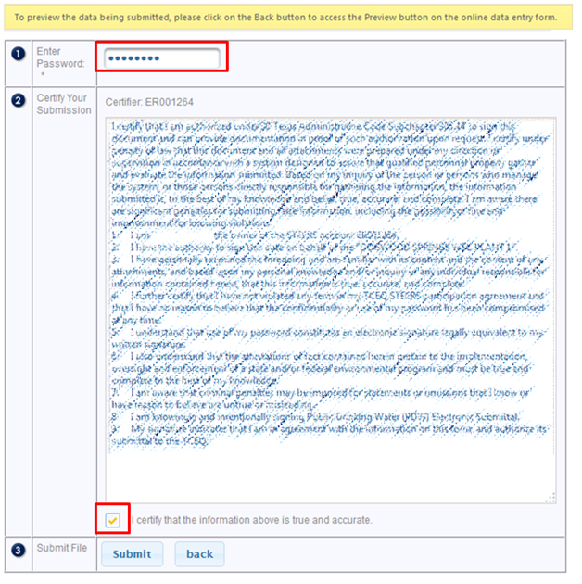

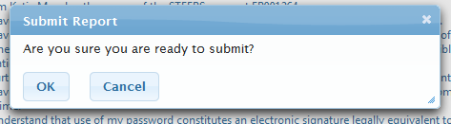

Once the “OK” button is pressed, E2 will call STEERS to validate the following.
- PWS user has provided the correct password
- PWS user has the correct role to “Sign and Submit” the report online

Step 11: Upon successful submission, the receipt page is displayed online as shown below.
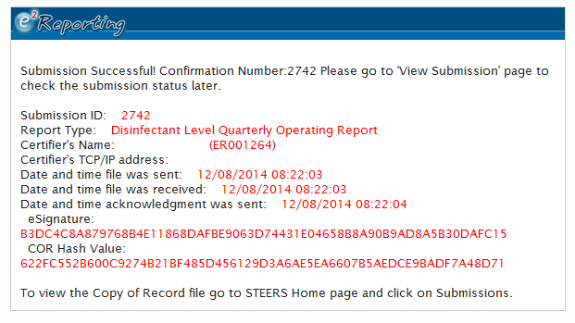

A “submission received” confirmation email will be sent to the submitter’s email address. Your report has not been successfully submitted until you receive this receipt. You may want to print the receipt page or confirmation email, as proof of submittal of the DLQOR.

Step 12: After the Disinfectant Level Quarterly Operating Report (DLQOR) is submitted in E2, it is available for review at any time under the “View Submission” menu option.

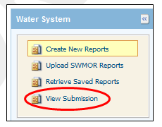

An example “View Submissions” page for the Water System Reports is shown below.

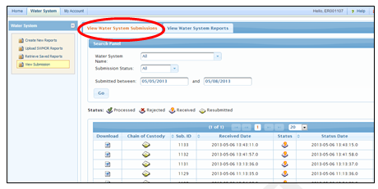

To find a particular submission, select/enter the desired search criteria as follows:
- Water System Name
- Submission status
- Submission date (from / to)

If you notice that the data you have submitted is wrong, or you need to revise the data, you will need to resubmit a corrected copy. Follow the steps to submit a new DLQOR, but this time you will need to add a note to the Report Comments section of the DLQOR form.

Add information such as “Correct Info” or “Revised data” to the Report Comments Section. If you do not add this information, we will not know which of the two reports you submitted is the correct one. This could lead to a delay in the processing of your information.

Step 13: Viewing Chain of Custody

The Chain of Custody can be obtained for the selected submission by pressing on the “Chain of Custody” icon.

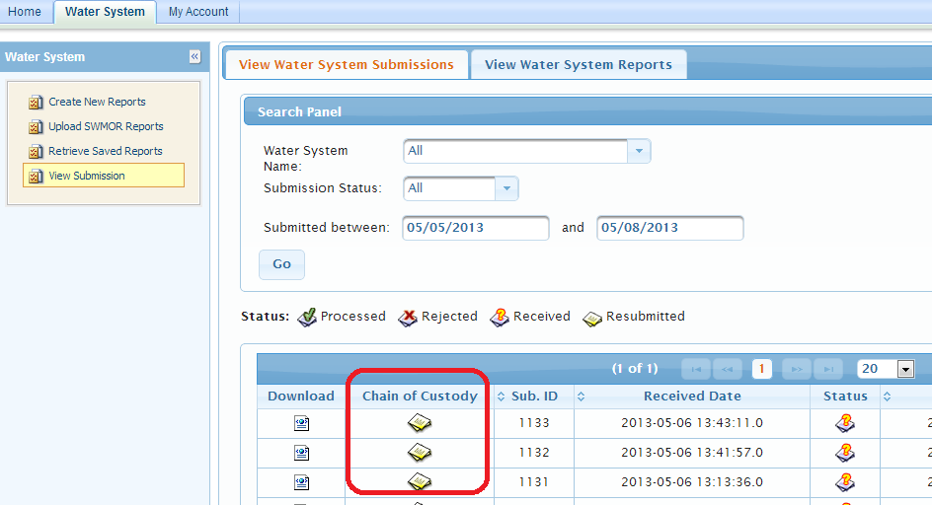

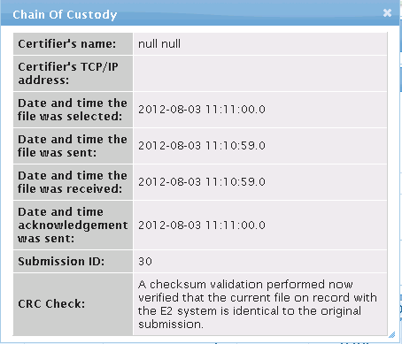

Step 14: Viewing / Printing the Submitted DLQOR Report

To view/print the submission in DLQOR Report Format (TCEQ FORM ID 20067), please follow the steps below:
- Press the “View Water System Reports” tab
- On the search panel, enter the desired public water system and reporting period criteria and press the “Go” button
- On the search result section, press the “View” icon for the desired record. This will open a window containing the DLQOR report displaying the submitted sample results.

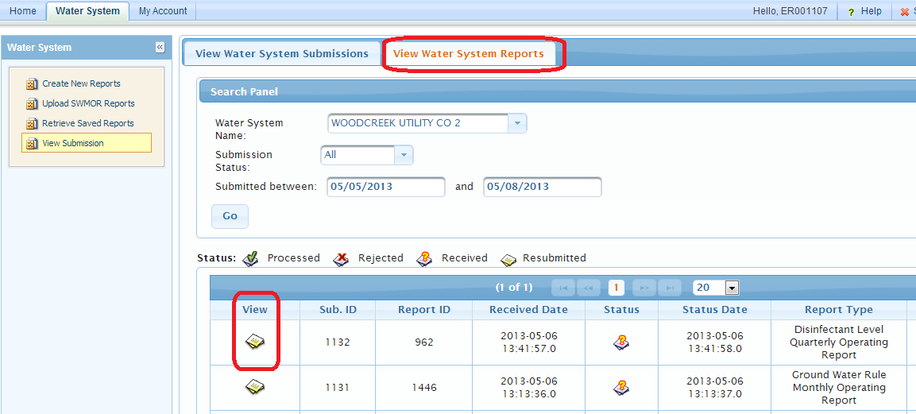

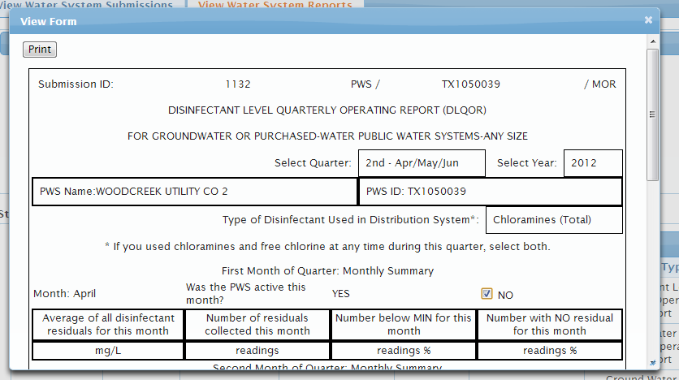

You can now print a copy of the submitted DLQOR for your records.

*Please note this page may not display properly in Firefox. If you have issues with the DLQOR form displaying properly, try to open and print the form using Google Chrome or Internet Explorer.

