Texas Commission on Environmental Quality
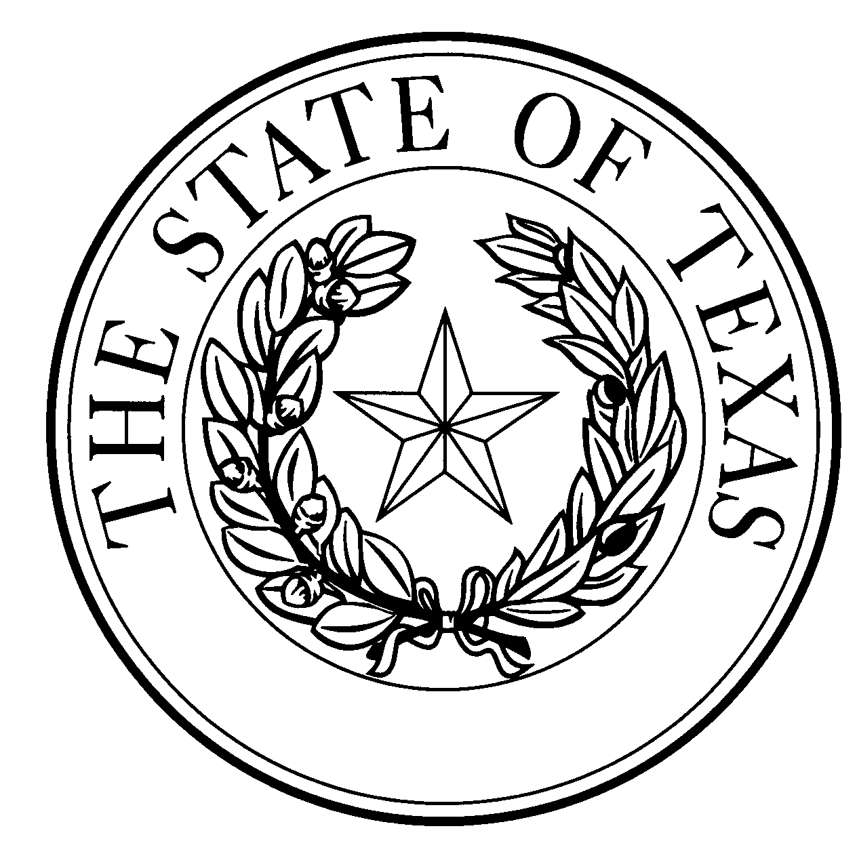
  - Notice of Concentrated Animal Feeding Operation Application
General Permit Authorization No. TXG921486
Application. Green Plains Cattle Company, LLC, 1811 Aksarben Drive, Omaha, NE, 68106 has applied to the Texas Commission on Environmental Quality (TCEQ) under General Permit No. TXG920000 for a non-substantial change to the terms of the nutrient management plan (NMP) previously submitted to the TCEQ. The Applicant is proposing to reduce the acreage of land management unit #3 North Circle from 360 to 274 acres. The 86 acres that was removed will no longer be in the permit and the property boundary has been adjusted accordingly. The total land application area will be reduced from 937 to 851 acres. The design calculations for retention control structures (RCS) #1 and #2 were revised due to the reduction in the RCSs drainage areas. The facility maps were updated to reflect these changes. The notice of change application and the updated NMP were received by TCEQ on August 14, 2020.
No discharge of pollutants into the waters in the state is authorized by this general permit except under chronic or catastrophic rainfall conditions or events. All waste and wastewater will be beneficially used on agricultural land.
The facility is located at 5150 Great Plains Drive, Hereford, Deaf Smith County, Texas. The facility is located in the drainage area of the Upper Prairie Dog Town Fork Red River in Segment No. 0229 of the Red River Basin. The following link to an electronic map of the site or facility’s general location is provided as a public courtesy and is not part of the application or notice. https://tceq.maps.arcgis.com/apps/webappviewer/index.html?id=db5bac44afbc468bbddd360f8168250f&marker=-102.48%2C35.033055&level=12. For the exact location, refer to the application.
The Executive Director of the TCEQ has approved the proposed non-substantial change to the terms of the NMP. The revised terms of the NMP have been included in the permit record and it is available at the TCEQ’s Central Records, 12100 Park 35 Circle Austin, Texas 78753.
Information. For additional information about this application, contact Kayla Robichaux at (512) 239-4742. Si desea información en Español, puede llamar al 1-800-687-4040. General information regarding the TCEQ can be found at our web site at www.tceq.texas.gov/.

Issued: January 14, 2021

