Submitted to TCEQ: April 22, 2022
Published as AS-xxx by TCEQ: Month dd, yyyy

Draft Updated Implementation Plan for Nine Total Maximum Daily Loads for Indicator Fecal Bacteria in Four Austin Streams
Assessment Units: 1403J_01, 1403K_01, 1428B_01, 1428B_02, 1428B_03, AU 1428B_04, 1428B_05, 1429C_02, and 1429C_03
Developed and Approved by the Improving Austin Streams Stakeholders
Published by the Texas Commission on Environmental Quality
Office of Water, Water Quality Planning Division
Prepared by the Improving Austin Streams Stakeholder Group
with support from
the University of Texas Center for Public Policy Dispute Resolution,
Suzanne Schwartz Facilitation, and
the Total Maximum Daily Load Team of
the Texas Commission on Environmental Quality
Submitted to the Texas Commission on Environmental Quality:
month, dd, yyyy
Published and distributed by the
Total Maximum Daily Load Team
Texas Commission on Environmental Quality
MC-203
P.O. Box 13087
Austin, Texas 78711-3087
E-mail: tmdl@tceq.texas.gov
Total maximum daily load implementation plans are also available on the
Texas Commission on Environmental Quality website at:
www.tceq.texas.gov/waterquality/tmdl
Organizations that took part in developing this document include:
University of Texas at Austin
City of Austin Watershed Protection Division
Austin Water
Travis County
Lower Colorado River Authority
Texas Department of Transportation
Austin Association of Home Builders, Represented by the Atwell Group
Austin Parks Foundation
Austin Neighborhoods Council
Colorado River Alliance
Environment Texas
Lone Star Chapter, Sierra Club
People Organized in Defense of Earth and Her Resources (PODER)
Shoal Creek Conservancy
Waller Creek Greenway Conservancy
TCEQ is an equal opportunity employer. The agency does not allow discrimination on the basis of race, color, religion, national origin, sex, disability, age, sexual orientation, or veteran status. In compliance with the Americans with Disabilities Act, this document may be requested in alternate formats by contacting TCEQ at 512-239-0010, or 800-RELAY-TX (TDD), or by writing PO Box 13087, Austin TX 78711-3087. We authorize you to use or reproduce any original material contained in this publication—that is, any material we did not obtain from other sources. Please acknowledge TCEQ as your source. For more information on TCEQ publications, visit our website at: tceq.texas.gov/publications. How is our customer service? tceq.texas.gov/customersurvey

Contents
Executive Summary 1
Introduction 2
TMDL Summary 4
Implementation Progress through 2020 9
Data Used in the Update 13
Management Measure 1: Resident Outreach 13
Sub-Measure 1.1. ANC Meetings Educational Outreach 13
Sub-Measure 1.2. ANC Newsletter Educational Outreach 15
Sub-Measure 1.3. People Organized in Defense of Earth and Her Resources (PODER) educational outreach efforts 16
Sub-Measure 1.4. Waterloo Greenway educational outreach and programming 18
Management Measure 2: Water Quality Monitoring 19
Sub-Measure 2.1. LCRA Volunteer Water Quality Monitoring 19
Management Measure 3: Domestic Pet Waste 20
Sub-Measure 3.1. Pet Waste Stations 20
Management Measure 4: Stormwater Treatment Strategies 21
Sub-Measure 4.1. Flood Control Projects 21
Sub-Measure 4.2. Water Quality Control Projects 22
Sub-Measure 4.3. Tree Protection Zones 23
Sub-Measure 4.4. Monitor Bacterial Levels 24
Control Action 1: Comply with MS4 Stormwater Management Plans 25
Measures in SWMPs to Reduce Bacteria Loading 26
Implementation Tracking, Sustainability, and Milestones 29
Water Quality Indicators 29
Communications Strategy 30
References 31

Figures
Figure 1. Upper Walnut Creek TMDL watersheds 5
Figure 2. Lower Walnut Creek TMDL watersheds 6
Figure 3. Waller Creek TMDL watersheds 7
Figure 4. Spicewood Tributary to Shoal Creek and Taylor Slough TMDL watersheds 8

Tables
Table 1. TMDL allocation summary for impaired AUs 9
Table 2. TMDL allocation summary for AUs of concern 9
Table 3. Management Measure 1.1. Austin Neighborhoods Council Meetings Educational Outreach. 14
Table 4. Management Measure 1.2. Austin Neighborhoods Council meetings educational outreach. 16
Table 5. Management Measure 1.3. PODER educational outreach effort 17
Table 6. Management Measure 1.4. Waterloo Greenway educational outreach and programming. 18
Table 7. Management Measure 2.1 Volunteer Water Quality Monitoring 20
Table 8. Management Measure 3.1. Pet Waste Stations. 21
Table 9. Management Measure 4.1. Flood Control Projects. 22
Table 10. Management Measure 4.2. Water Quality Controls. 23
Table 11. Management Measure 4.3. Tree Protection Zones. 23
Table 12. Management Measure 4.4. Monitor Bacterial Levels. 24
Table 13. MS4s permits and authorization in the Austin Streams TMDL watersheds 26
Table 14. Types of bacteria reduction BMPs implemented through SWMPs, University of Texas at Austin 27
Table 15. Types of bacteria reduction BMPs implemented through SWMPs, City of Austin 27
Table 16. Types of bacteria reduction BMPs implemented through SWMPs, County of Travis 28
Table 17. Types of bacteria reduction BMPs implemented through SWMPs, Texas Department of Transportation 28

Abbreviations
AU assessment unit
ANC Austin Neighborhoods Council
BMP best management practice
CoA City of Austin
COA WPD City of Austin Watershed Protection Division
cfu colony-forming units
E. coli Escherichia coli (a type of fecal bacteria)
EPA Environmental Protection Agency, United States
I-Plan implementation plan
LCRA Lower Colorado River Authority
MCM minimum control measure
mL milliliter
MS4 municipal separate storm sewer system
OSSF on-site sewage facility
PODER People in Defense of the Earth and her Resources
SSO sanitary sewer overflow
SWMP stormwater management plan
TCEQ Texas Commission on Environmental Quality
TMDL total maximum daily load
TPDES Texas Pollutant Discharge Elimination System
TxDOT Texas Department of Transportation
UTA University of Texas at Austin
WWTF wastewater treatment facility

Executive Summary
The Texas Commission on Environmental Quality (TCEQ) identified elevated concentrations of indicator fecal bacteria in 2002 and 2006 in four Austin streams, which may indicate a health risk to people who swim or wade in the water bodies—activities called “contact recreation” in the state’s standards for surface water quality. TCEQ measures single-sample and geometric-mean concentrations of Escherichia coli (E. coli) bacteria to indicate whether the contact recreation use is attained in freshwater streams and lakes.
The impairments were first noted in the Spicewood Tributary to Shoal Creek (Segment 1403J) and Taylor Slough South (1403K) in the 2002 Texas Water Quality Inventory and 303(d) List (TCEQ 2002) and were added for Waller Creek (1429C) and Walnut Creek (1428B) in 2006 (TCEQ 2006). An assessment unit (AU) is the smallest geographic area for which TCEQ reports use attainment. The impaired segments and the five affected AUs within them in the Austin area are:
- Spicewood Tributary to Shoal Creek, AU 1403J_01
- Taylor Slough South, AU 1403K_01
- Walnut Creek, AU 1428B_05
- Waller Creek, AUs 1429C_02 and 1429C_03
TCEQ identified concerns for continued attainment of the contact recreation use in four AUs of Walnut Creek in the 2012 Texas Integrated Report of Surface Water Quality for Clean Water Act Sections 305(b) and 303(d) (TCEQ 2012). Those AUs are:
- Walnut Creek, AU 1428B_01
- Walnut Creek, AU 1428B_02
- Walnut Creek, AU 1428B_03
- Walnut Creek, AU 1428B_04
On January 21, 2015, TCEQ adopted Five Total Maximum Daily Loads for Indicator Bacteria in Four Austin Streams (TMDLs) to address the impairments (TCEQ 2015a). The U.S. Environmental Protection Agency (EPA) approved the TMDLs on March 18, 2015. After EPA guidelines were revised early in 2015 to allow TMDLs for concerns as well as for impairments, at the request of the Improving Austin Streams stakeholder group, TCEQ added four TMDLs for the AUs of concern via the April 2015 Update to the Texas Water Quality Management Plan (TCEQ 2015c). The TMDL report and the TMDL update established the maximum amount of indicator bacteria the water bodies could assimilate and still meet the state’s contact recreation use standards.
In addition to advising TCEQ on development of the TMDLs, the Improving Austin-Streams stakeholder group developed their Implementation Plan for Five Total Maximum Daily Loads for Bacteria in Four Austin Streams (I-Plan) (TCEQ 2015b) to reduce indicator bacteria in the affected water bodies, which TCEQ approved on January 21, 2015. TCEQ and the stakeholders considered the I-Plan to be adequate, without revision, to implement the four AUs added via the Texas Water Quality Management Plan. The TMDLs, the 2015 I-Plan, and this Updated I-Plan are available on TCEQ’s Austin Area Streams TMDL project webpage (project webpage)..
The goal of this Updated I-Plan is to continue reducing indicator bacteria concentrations to attain the contact recreation use assigned to the nine affected AUs. Stakeholders in the watershed will implement this I-Plan through voluntary management measures and regulatory control actions. Stakeholders will use an adaptive management approach to carry out the I-Plan, in which they assess the efficiency and effectiveness of the measures they implement and adjust for changing conditions.
This Updated I-Plan summarizes the nine TMDLs adopted by TCEQ in January 2015 and the progress stakeholders achieved under their 2015 I-Plan, which TCEQ also approved in 2015. The Updated I-Plan also identifies the specific management measures and control actions the stakeholders will use to reduce bacteria concentrations, the parties responsible for implementing each measure or action, and a schedule for completing them.
The 2015 TMDL report identified the probable sources of e. coli in Austin streams as stormwater runoff from municipal separate storm sewer systems (MS4s), malfunctioning on-site sewage facilities (OSSFs), urban development, and pet and wildlife wastes.
Organizations that have MS4 permits or authorizations in the four Austin streams watersheds (TMDL watersheds) are the City of Austin (CoA), University of Texas at Austin (UTA), Texas Department of Transportation (TxDOT), and Travis County. No domestic wastewater treatment facilities (WWTFs) discharge within the TMDL watersheds.
Responsible parties will report their progress to the TCEQ TMDL Team annually in April and will meet each May to assess their progress and adjust implementation strategies as needed. TCEQ will post the stakeholders’ annual status reports on the Austin Area Streams TMDL project webpage.

Introduction
The Austin area is located inside Travis County where the Edwards Plateau meets the Blackland Prairie at the Balcones Fault (commonly called the Texas Hill Country) according to the 2013 Texas Almanac (TSHA 2013). The four watersheds of concern may be found in the central and western areas of Austin and are located on the Balcones Escarpment, at the eastern edge of the Edwards Plateau. Land use in these TMDL watersheds is primarily urban (TCEQ 2015a).
In June 2021, after six years implementing their original I-Plan, the stakeholders decided to update their I-Plan based on currently available data and science and what they learned about the effectiveness of their chosen best management practices (BMPs). The stakeholder group was open to all individuals or representatives of organizations who either:
1) Live or work in the affected watersheds
2) Are affected by or may affect water quality in the watersheds
3) Are able to develop and or implement actions to reduce water quality problems
Stakeholders formed a Coordinating Committee to guide development of the updated plan and serve as a decision-making group, with the goal of making all decisions by consensus. Completion assignments related to writing the report were distributed to members based on interests and abilities.
Stakeholders’ goals for the Updated I-Plan are to:
- Manage the affected watersheds through cooperation among jurisdictions and residents, and by tailoring solutions to each responsible party’s unique needs.
- Improve water quality to meet the criterion used to measure the attainment of the contact recreation use.
This updated I-Plan reflects the management measures and control actions that responsible parties will implement to meet those goals for the affected watersheds. One important point for holders of TCEQ MS4 permits was to ensure that the revised I-Plan was flexible enough to reflect changes in the actions required under their MS4 permits so as not to impose additional voluntary actions that might then become mandatory under said permits. Throughout the process of developing the update, stakeholders considered the issue of how best to involve the public, both in developing the updated I-Plan as well as in actions to improve water quality.
The group agreed to provide annual reporting about the plan’s implementation each April followed by an annual meeting in May to assess progress and make any needed changes in implementation or management measures and control actions.

TMDL Summary
A TMDL represents the maximum amount of a pollutant that a water body can receive in a single day without exceeding water quality standards. TCEQ, with advice from the stakeholders, developed TMDLs for the five impaired AUs identified on the Texas 303(d) list of impaired water bodies, and as requested by the Austin Streams stakeholders, developed TMDLs for the four AUs with concerns for continued attainment of the contact recreation use. Bacteria TMDLs for freshwaters are typically expressed in billion colony-forming units per day (cfu/day) of E. coli.
Figure 1 through 4 are maps developed by TCEQ showing the approximate locations and areas of the affected watersheds. Tables 1 and 2 summarize the allocations developed for the Five Total Maximum Daily Loads for Bacteria in Four Austin Streams (TCEQ 2015a) and the four TMDLs added in the April 2015 Update to the Texas Water Quality Management Plan (TCEQ 2015c). The TMDL report and update, available on TCEQ’s Austin Area Streams TMDL project webpage, provide additional background information, including the problem definition, endpoint identification, source analysis, linkages between sources and receiving waters, and pollutant load allocations.
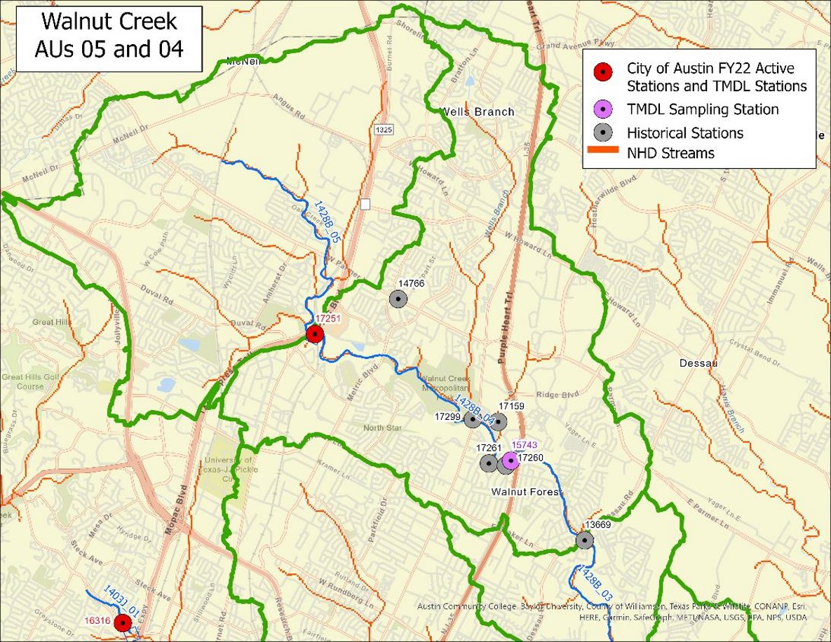
Figure 1. Upper Walnut Creek TMDL watersheds
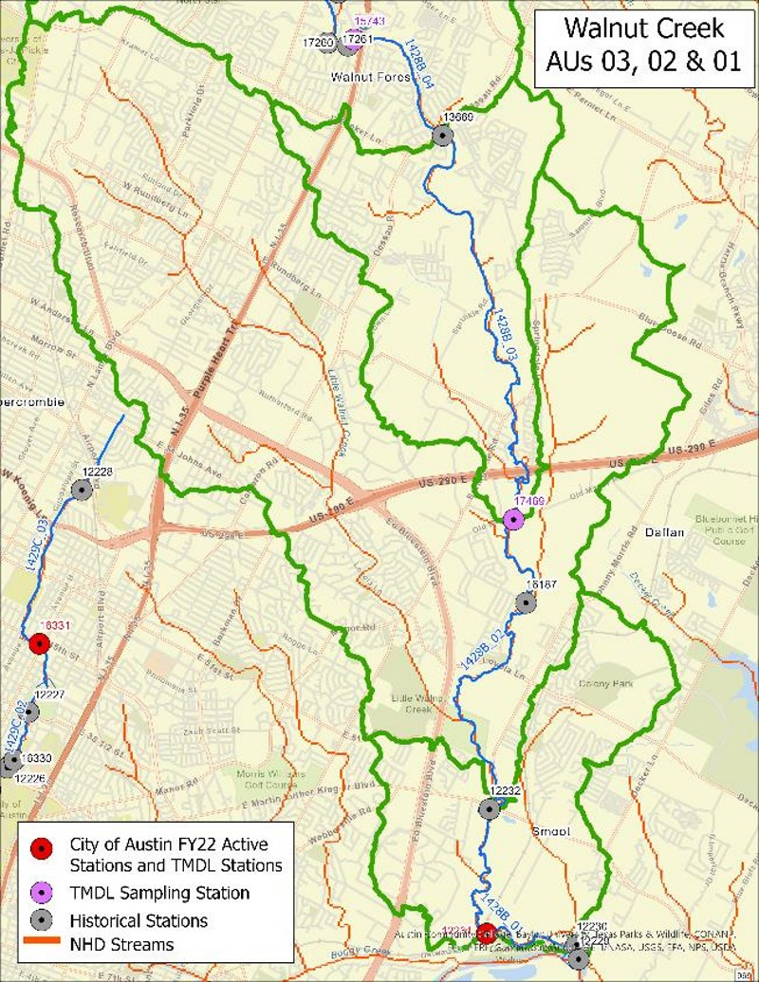
Figure 2. Lower Walnut Creek TMDL watersheds
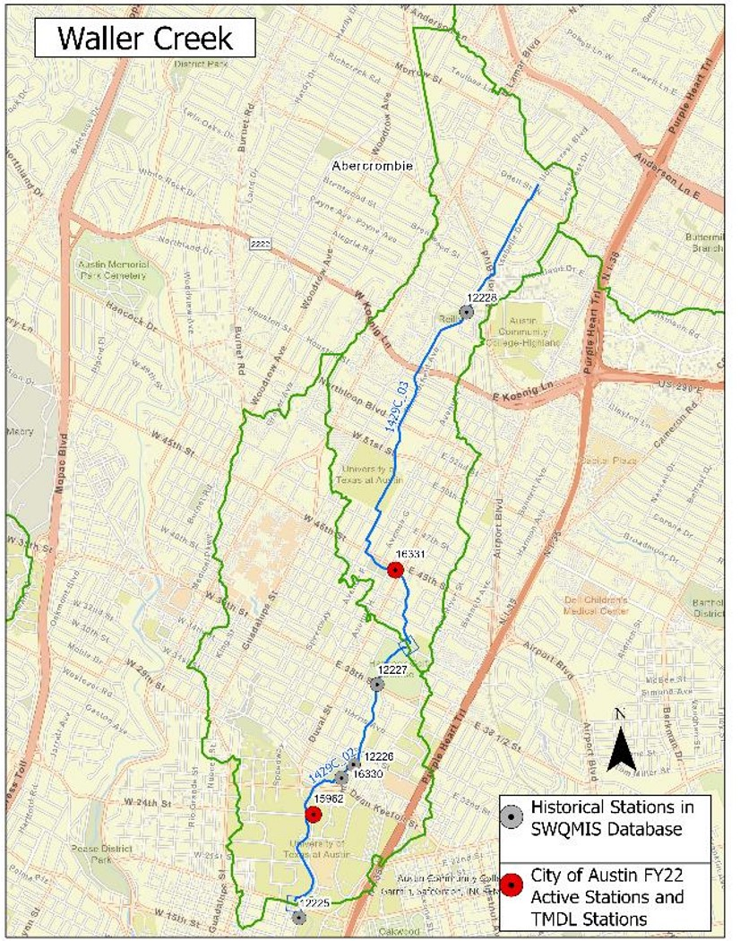
Figure 3. Waller Creek TMDL watersheds
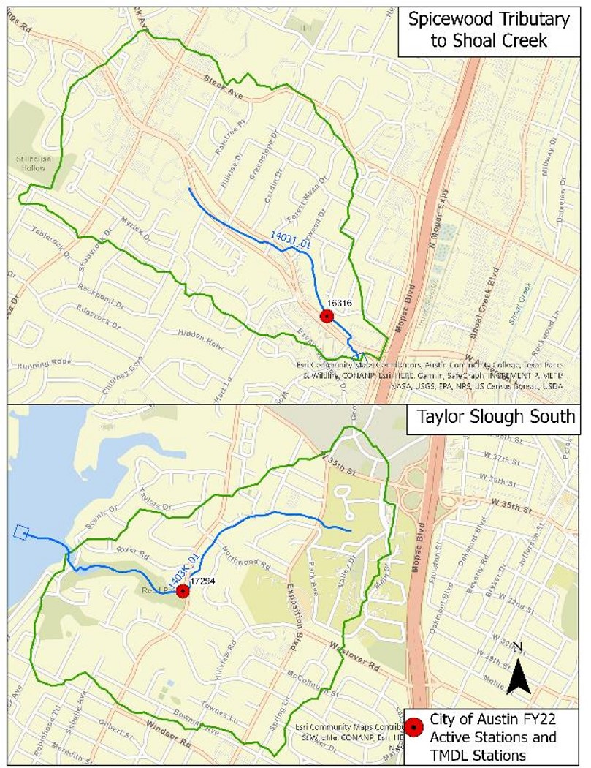
Figure 4. Spicewood Tributary to Shoal Creek and Taylor Slough TMDL watersheds
Table 1. TMDL allocation summary for impaired AUs
Loads are provided in billion cfu/day.
Stream | AU | TMDL | WLA_{WWTF} | WLA_{SW} | MOS | LA_{USL} | LA_{AU} | LA_{Total}
Spicewood Tributary to Shoal Creek | 1403J_01 | 11.93 | 0.00 | 11.33 | 0.60 | 0.00 | 0.00 | 0.00
Taylor Slough South | 1403K_01 | 9.93 | 0.00 | 9.43 | 0.50 | 0.00 | 0.00 | 0.00
Walnut Creek | 1428B_05 | 74.91 | 0.00 | 71.16 | 3.75 | 0.00 | 0.00 | 0.00
Waller Creek | 1429C_02 | 90.29 | 0.00 | 50.72 | 2.67 | 36.90 | 0.00 | 36.90
Waller Creek | 1429C_03 | 36.90 | 0.00 | 35.05 | 1.85 | 0.00 | 0.00 | 0.00
Table 2. TMDL allocation summary for AUs of concern
Loads are provided in billion cfu/day.
Stream | AU | TMDL | WLA_{WWTF} | WLA_{SW} | MOS | LA_{USL} | LA_{AU} | LA_{Total}
Walnut Creek | 1428B_01 | 283.36 | 0.00 | 17.89 | 0.94 | 264.53 | 0.00 | 264.53
Walnut Creek | 1428B_02 | 264.53 | 0.00 | 87.89 | 4.63 | 172.01 | 0.00 | 172.01
Walnut Creek | 1428B_03 | 172.01 | 0.00 | 10.16 | 0.53 | 161.32 | 0.00 | 161.32
Walnut Creek | 1428B_04 | 161.32 | 0.00 | 82.09 | 4.32 | 74.91 | 0.00 | 74.91
Detailed information about the TMDLs and the original I-Plan is available in Five Total Maximum Daily Loads for Indicator Bacteria in Four Austin Streams (TCEQ 2015) and the Implementation Plan for Five Total Maximum Daily Loads for Bacteria in Four Austin Streams (TCEQ 2015), both available on TCEQ’s Austin TMDL project webpage.

Implementation Progress through 2020
The TCEQ worked with stakeholders and interested governmental agencies to track the progress of the previous plan throughout the 2015-2020 implementation period. To ensure accountability for reducing potential bacterial sources and meeting targets for progress under the IAS TMDL, annual updates on the agreed upon commitments and requirements were provided to the TCEQ by each participating entity. As part of this accountability framework, stakeholders agreed to develop short term goals, called milestones, to ensure progress. The yearly milestones represented key check-in points on the way to pollutant reduction in the five identified Austin area streams. These milestones provide specificity of load reduction, rigorous assurances that load reduction will be achieved, and transparent reporting to the public. A summary of key milestones throughout the implementation period is provided below for each of the five management measures.
As of 2020, additional riparian zone restoration has been achieved throughout the watersheds of the identified streams. Grow zones were evaluated and expanded by three acres, and all eligible parks in Walnut, Waller, and Taylor Slough watersheds were adopted. Volunteers facilitated additional public education about Grow Zone and Restoration plans and were provided information about creek-side restoration work and Land Stewardship Plans. The riparian buffer zone width for new development was increased and subsequently 20 miles of riparian buffer in the impacted watersheds has been protected.
Within the City of Austin (COA), all on-site sewage facilities (OSSF) were connected to a centralized wastewater collection system by 2020. Travis County approved a fee waiver to incentivize owners to choose a proactive remedy rather than defer action on OSSF repairs. A total of 42,000 linear feet of sewer lines were rehabilitated, 66 sanitary sewer overflows were responded to and remediated, and three additional public toilets were installed.
To address pet waste, signage was updated in all watersheds and an extensive Scoop-the-Poop public education campaign was conducted. The campaign included assigning rangers to patrol parks and provide info about pet waste regulations, outreach over social media, and event attendance to spread awareness. 140 mounted trash cans, routinely stocked with pet waste bags, were installed at City maintained parks. Educational kiosks were also installed at the Walnut Creek Park off-leash area.
Several types of residential outreach were conducted throughout the implementation period. Briefings on proposed fecal contamination reduction strategies were provided to the Austin Environmental Board and education on programs to reduce fecal contamination was provided in Austin Neighborhoods Council meetings. Educational materials on the water quality impacts from outdoor defecation were made available to homeless through the nonprofit House for Homeless, and the COA began working on a more robust campaign focused on homelessness issues. Scoop-the-Poop messaging has been incorporated into Earth Camp and two other presentations to Austin Independent School District classes. This messaging was also incorporated into Austin Park Foundation and Keep Austin Beautiful volunteer training and at several volunteer engagement events.
There were numerous structural stormwater treatment strategies executed between 2015 and 2020. Two water-quality retrofits were installed at the headwaters of Waller Creek, and 65 additional acres were modified to remove pollutants from runoff. 2,900 inspections were conducted to ensure proper operations and maintenance of water quality controls. All storm drain outfalls greater than 36 inches were screened for dry-weather flows and investigated as needed to identify and resolve illicit discharges. Erosion and sedimentation control plans were enforced on all exterior construction projects, and over 200 inspections were conducted to ensure compliance and address deficiencies. Inspections of industrial facilities for evidence of illicit discharges were completed, with no violations for offsite discharge issued.
The status reports submitted by the IAS stakeholders during the previous I-Plan were a useful tool in tracking progress towards the targeted bacterial load reduction and ensuring transparency with the public. For a more detailed breakdown of individual stakeholder achievements, refer to the implementation status tables on the TCEQ’s Austin TMDL project webpage. The following revised implementation strategy will both build upon the previous stakeholder commitments and continue those practices that have been demonstrated as effective.

Implementation Strategy
This revised I-Plan documents management measures and control actions to reduce bacteria loads. Management measures are voluntary activities, such as restoring and improving riparian buffer zones. Control actions are regulatory activities, such as compliance with WWTF or MS4 permits.
The participating partners may accomplish the activities described in the plan through rule, order, guidance, or other formal or informal action. The Updated I-Plan will be implemented using adaptive management, wherein measures are periodically assessed for efficiency and effectiveness and revised as needed. This iterative process for evaluating and adjusting the management measures and control actions will ensure continuing progress toward achieving water quality goals and shows a commitment to improving water quality.
Management measures may be adjusted or eliminated by agreement of the stakeholders during each annual assessment of progress or when the time period for this plan has been completed. Control actions will be adjusted based on changes in the regulations and permits that form their basis, including adding or removing actions needed to comply with applicable permits.

Management Measures Summary
This plan contains four categories of management measures, organized by approach to reduction of the pollutant), as follows:
  - Resident Outreach (Management Measure 1.0)
  - Water Quality Monitoring (Management Measure 2.0)
  - Domestic Pet Waste (Management Measure 3.0)
  - Stormwater Treatment Strategies (Management Measure 4.0).
Each management measure is comprised of the sub-measures which will be implemented. Sub-measures contain a narrative description, and are further organized around a table summarizing each management measure in a format describing:
  - the best management practice;
  - responsible party;
  - area of emphasis;
  - educational component;
  - schedule for implementation;
  - interim, measurable milestones;
  - progress indicators; and
  - monitoring component, if applicable.

Control Actions Summary
The control actions in this plan are drawn from the activities of responsible parties that hold MS4 Phase I individual permits or Phase II general permit authorizations issued under TCEQ’s Texas Pollutant Discharge Elimination System (TPDES) program. The purpose of MS4 permits is to reduce discharges of pollutants in stormwater to the “maximum extent practicable.” Permit holders must develop and implement SWMPs that implement minimum control measures (MCMs) with best management practices (BMPs) to minimize the discharge of pollutants in stormwater. MCMs are established by TCEQ and EPA and are described in individual and general MS4 permits. SWMPs will be included by reference in this I-Plan update, since the schedules for revising the I-Plan and the SWMPs do not usually coincide. The I-Plan update provides a webpage link to the SWMPs so that stakeholders are always able to access both the latest approved plan and the latest proposed plan pending TCEQ or EPA approval.
The plan also includes a description of the general types of applicable BMPs that the MS4 permit holders are implementing by the inclusion of tables for each MS4 entity. The BMPs are organized around the following sources of pollution or activities, depending on the MS4 permittee:
- sanitary sewer systems;
- onsite sewage facilities;
- wastewater infrastructure;
- illicit discharges and dumping;
- animal sources;
- resident education;
- monitoring, evaluation and reporting;
- riparian zone restoration; and
- stormwater treatment.

Data Used in the Update
*Text for this section will be sent separately.

Management Measure 1: Resident Outreach
1.1.-1.2. Austin Neighborhoods Council educational outreach (ANC)
The ANC acts as a coordinating body for the efforts of Austin-area neighborhood groups, as a clearinghouse for information and to give guidance in all matters of concern and wellbeing to individual neighborhoods and/or the City of Austin. The ANC is comprised of volunteer representatives of member neighborhood associations. Member neighborhood associations are organized into 10 geographic sectors, each sector being represented on the ANC Executive Committee.
Meetings of the ANC are open to the public when held in a public physical location. Meeting notices and agendas are emailed to representatives of member neighborhood associations in advance on the Austin Neighborhoods Council meetings. Meeting minutes and PowerPoint presentations are available on the ANC website (www.atxanc.org).
The ANC researches plans, resolutions, ordinances, and legislation which affect neighborhoods in the Austin area and makes specific recommendations. ANC strives to make a positive contribution to Austin through the betterment of our neighborhoods by promoting civic awareness and education through forums, seminars, workshops, etc., on those subjects relating to neighborhood concerns. The ANC encourages and endorses individuals who are responsive to the needs of the neighborhoods.

Sub-Measure 1.1. ANC Meetings Educational Outreach

The ANC generally employs two ways to distribute educational material and program information on water quality issues: passively, in which COA staff members set up information tables at monthly general membership meetings to engage interested ANC members before the meeting or by broadcast to member neighborhood associations by internet communication and actively, when ANC invites COA staff to present information and distribute material and answer questions during general membership or sector meetings. This strategy addresses active distribution. It envisions at least one annual visit by COA staff to address water quality issues.

As part of this Plan, the ANC will request annual briefings from COA staff on specific topics relevant to the fecal bacteria TMDL including riparian zone restoration, pet waste collection, water quality structural BMP retrofits, fecal contamination reduction public education, wastewater infrastructure maintenance, development of public toilets and in-stream fecal bacteria monitoring results. These strategies address a wide range of potential sources of fecal contamination.

Briefings will occur at regular monthly general membership meetings of the ANC at least once per year for 5 years. For those sectors that meet, staff will also be invited to give briefings at sector meetings at least once per year for 5 years. It is within the existing purview of the ANC to request briefings from city staff. While the ANC does not make city policy, it may enhance the fecal load reduction from other COA initiated implementation strategies by providing an additional means of public education and outreach and offering a potential public venue for adaptive management discussions should strategies be determined to need modification during implementation. The ANC may, as a result of briefings, act to offer guidance to COA.
Table 3. Management Measure 1.1. Austin Neighborhoods Council Meetings Educational Outreach.
Item | Description
Best Management Practice | The ANC will invite COA–Water Protection Division (WPD) staff to attend one citywide general meeting and one meeting for each sector (or group of sectors) per year to provide information on COA programs that may reduce fecal contamination and ways in which citizens or neighborhood associations may voluntarily participate. Topics for discussion by COA staff may include riparian zone restoration efforts, pet waste collection, environmental problem identification and reporting, private wastewater lateral inspections, and instream monitoring results.
Responsible Party | Austin Neighborhoods Council
Area of Emphasis | Community education
Educational Activities | Presentations on the status of COA programs included in the I-Plan will serve as a means to inform and update the public and provide a means for citizens to voluntarily implement fecal reduction measures through COA volunteer programs. COA may provide content for neighborhood association newsletters, or links to COA web-based content for email notifications.
Schedule of Implementation | Years 1 through 5: ANC will invite COA WPD staff to brief the citywide general meeting and each sector (or group of sectors) once per year on COA environmental programs and ways citizens may help to reduce fecal contamination.
Interim, Measurable Milestones | The number of briefings to ANC citywide general meeting and individual sector meetings per year will be measured and reported.
Progress Indicators | COA strategies propose to reduce fecal loads to creeks and reduce instream fecal indicator bacteria concentrations. This strategy contains public education elements that will support those actions.
Monitoring Component | - The number of briefings to ANC sectors will be tracked annually.  - Water quality monitoring will continue in each of the affected watersheds as part of COA participation in the Texas Clean Rivers Program in partnership with the Lower Colorado River Authority (LCRA).

Sub-Measure 1.2. ANC Newsletter Educational Outreach

The ANC generally employs two ways to distribute educational material and program information on water quality issues: passively, in which COA staff members set up information tables at monthly general membership meetings to engage interested ANC members before the meeting or by broadcast to member neighborhood associations by internet communication and actively, when ANC invites COA staff to present information and distribute material and answer questions during general membership or sector meetings. This strategy addresses distribution articles for distribution to member neighborhood associations

As part of this Plan, the ANC will request informational articles from the COA staff on topics relevant to the fecal bacteria TMDL including riparian zone restoration, pet waste collection, water quality structural BMP retrofits, fecal contamination reduction public education, wastewater infrastructure maintenance, development of public toilets and in-stream fecal bacteria monitoring results. These strategies address a wide range of potential sources of fecal contamination.

ANC will distribute these articles to member neighborhood associations and invite them to publish the articles in their neighborhood newsletters or otherwise distribute them to the member neighborhood associations’ members. ANC will request articles at least annually. It is within the existing purview of the ANC to request article from city staff. ANC does not mandate content of the newsletters. While the ANC does not make city policy, it may enhance the fecal load reduction from other COA initiated implementation strategies by providing an additional means of public education and outreach and offering a potential public venue for adaptive management discussions should strategies be determined to need modification during implementation. The ANC may, as a result of briefings, act to offer guidance to COA
Table 4. Management Measure 1.2. Austin Neighborhoods Council meetings educational outreach.
Item | Description
Best Management Practice | The ANC will request informational articles from the COA staff on topics relevant to the fecal bacteria TMDL including riparian zone restoration, pet waste collection, water quality structural BMP retrofits, fecal contamination reduction public education, wastewater infrastructure maintenance, development of public toilets and in-stream fecal bacteria monitoring results. These strategies address a wide range of potential sources of fecal contamination. ANC will distribute these articles to member neighborhood associations and invite them to publish the articles in their neighborhood newsletters or otherwise distribute them to the member neighborhood associations’ members. ANC will request articles at least annually.
Responsible Party | Austin Neighborhoods Council
Area of Emphasis | Community education
Educational Activities | Articles distributed to member neighborhoods will serve as a means to inform and update the public and provide a means for citizens to voluntarily implement fecal reduction measures through COA volunteer programs. COA may provide content for neighborhood association newsletters, or links to COA web-based content for email notifications.
Schedule of Implementation | Years 1 through 5: ANC will request COA staff to provide articles once per year on COA environmental programs and ways citizens may help to reduce fecal contamination.
Interim, Measurable Milestones | The number of articles ANC distributes to its member associations per year.
Progress Indicators | COA strategies propose to reduce fecal loads to creeks and reduce instream fecal indicator bacteria concentrations. This strategy contains public education elements that will support those actions.
Monitoring Component | - The number of articles ANC requests and distributes to its member neighborhood associations sectors will be tracked annually.  - Water quality monitoring will continue in each of the affected watersheds as part of COA participation in the Texas Clean Rivers Program in partnership with the LCRA.

Sub-Measure 1.3. People Organized in Defense of Earth and Her Resources (PODER) educational outreach efforts

PODER is a grassroots environmental justice organization in East Austin, led by women of color, that defines the “environment” as the place we live, work, learn, play, and pray; and for that reason it addresses multiple social and environmental issues affecting the communities as basic human rights.

PODER is a member of the Hispanic Advocates Business Leaders of Austin (HABLA), which is a “Think Tank” group and forum made up of local Hispanic/Latino community and business leaders committed to discussing and developing sustainable solutions on current affairs, public policies, and quality of life issues impacting the local Austin Hispanic/Latino community. HABLA members meet monthly at Juan in a Million Restaurant.

PODER is also a member of La Raza Roundtable which brings together community organizations, community leaders, elected officials private, and public sector representatives in leadership capacities that impact positive change for La Raza. La Raza Roundtable meets every Saturday at Mexitas Bingo Hall.

As part of this Plan, PODER will request annual briefings from the COA staff on specific topics relevant to the fecal bacteria TMDL including riparian zone restoration, pet waste collection, water quality structural BMP retrofits, fecal contamination reduction public education, wastewater infrastructure maintenance, development of public toilets and in-stream fecal bacteria monitoring results. These strategies address wide range potential sources of fecal contamination. PODER will distribute updates at the HABLA and La Raza Roundtable meetings. PODER will provide links on its website (www.poderaustin.org) regarding the Austin bacteria TMDL I-Plan and other available resources.

Table 5. Management Measure 1.3. PODER educational outreach effort
Item | Description
Best Management Practice | PODER will request annual briefings from the COA staff on specific topics relevant to the fecal bacteria TMDL including riparian zone restoration, pet waste collection, water quality structural BMP retrofits, fecal contamination reduction public education, wastewater infrastructure maintenance, development of public toilets and in-stream fecal bacteria monitoring results. These strategies address wide range potential sources of fecal contamination. PODER will distribute updates at the HABLA and La Raza Roundtable meetings. PODER will provide links on its website (www.poder-texas.org) regarding the Austin bacteria TMDL I-Plan and other available resources.
Responsible Party | PODER
Area of Emphasis | Community education
Educational Activities | Presentations on the status of COA programs included in the I-Plan measures will serve as a means to inform and update the public, and provide a means for citizens to voluntarily implement fecal reduction measures through COA volunteer programs. COA may provide content for PODER, HABLA and La Raza meetings and links to COA web-based content.
Schedule of Implementation | Years 1-5: PODER will:  -Request annual briefings by COA WPD staff on COA environmental programs and ways citizens may help to reduce fecal contamination.  -Distribute updates at the HABLA and La Raza Roundtable meetings annually.  -Provide links on its website (www.poderaustin.org regarding the Austin bacteria TMDL I-Plan and other available resources.
Interim, Measurable Milestones | -The number of briefings to PODER per year will be measured and reported.  -The number of updates by PODER to HABLA, La Raza and others per year will be reported.
Progress Indicators | COA strategies propose to reduce fecal loads to creeks and reduce instream fecal indicator bacteria concentrations. This strategy contains public education elements that will support those actions.
Monitoring Component | -The number of briefings to PODER by COA staff will be tracked annually, as will be updates distributed by PODER to other organizations.  -Water quality monitoring will continue in each of the affected watersheds as part of COA participation in the Texas Clean Rivers Program in partnership with the LCRA.

Sub-Measure 1.4. Waterloo Greenway educational outreach and programming

Waterloo Greenway Conservancy creates and maintains an extraordinary urban park system and a restored Waller Creek, in partnership with the City of Austin, for the benefit of all. The Conservancy renews the natural environment, promotes play, health and wellness, economic vitality and mobility, and engages the community through outreach, education, cultural events, and the arts. Waterloo Greenway Conservancy will develop communications to educate Waterloo Greenway users and neighbors about the watershed, ongoing creek restoration work, and water quality updates in collaboration with COA-WPD & PARD, via newsletter, website, and social media.
Table 6. Management Measure 1.4. Waterloo Greenway educational outreach and programming.
Item | Description
Best Management Practice | Waterloo Greenway Conservancy will develop communications to educate Waterloo Greenway users and neighbors about the watershed, ongoing creek restoration work, and water quality updates in collaboration with COA-WPD & PARD, via newsletter, website, and social media.
Responsible Party | Waterloo Greenway Conservancy
Area of Emphasis | Community Education and Outreach
Educational Activities | Educate users and neighbors of Waterloo Greenway about the watershed, ongoing creek restoration work, and water quality updates through forums such as Waterloo Greenway newsletters, blog posts, and park events.
Schedule of Implementation | Year 1:  Develop outreach strategy and materials/content
Year 2:
Distribute digital content twice a year and host one environmentally-focused event per year
Year 3:
Distribute digital content twice a year and host one environmentally-focused event per year
Year 4:
Distribute digital content twice a year and host one environmentally-focused event per year
Year 5:
Distribute digital content twice a year and host one environmentally-focused event per year
Interim, Measurable Milestones | - Two (2) digital content distributions per year  - One (1) environmentally-focused event per year
Progress Indicators | COA strategies propose to reduce fecal loads to creeks and reduce instream fecal indicator bacteria concentrations. This strategy contains public education elements that will support those actions.
Monitoring Component (if applicable) | -Number of times per year materials or educational messages are distributed and events held  *Water quality monitoring will continue in each of the affected watersheds as part of COA participation in the Texas Clean Rivers Program in partnership with the LCRA.

Management Measure 2: Water Quality Monitoring

Sub-Measure 2.1. LCRA Volunteer Water Quality Monitoring
The Lower Colorado River Authority (LCRA) provides public power, manages the lower Colorado River, builds and operates transmission lines across the state, and more. LCRA’s mission is to enhance the quality of life for the Texans served through water stewardship, energy and community service.
The Colorado River Watch Network (CRWN) is a program of the Water Quality Protection department at LCRA. CRWN is the first and largest regional volunteer network of water quality monitors in Texas. Trained volunteers submit water quality data that is reviewed and analyzed by CRWN staff, creating an early warning system that alerts LCRA to potential water quality threats. CRWN requires a two-year commitment to the monthly monitoring, and many volunteers have been participating for five to 10 years. All testing equipment is loaned to a monitoring group or individual, and supplies are restocked regularly.
LCRA will work to recruit, train, and educate citizen volunteers to conduct water quality monitoring on the four affected waterways to supplement professional monitoring data collected and reported to TCEQ through the Texas Clean Rivers Program.
Table 7. Management Measure 2.1 Volunteer Water Quality Monitoring
Item | Description
Best Management Practice | Volunteer Water Quality Monitoring
Responsible Party | LCRA
Area of Emphasis | Water Quality Monitoring
Educational Activities | Recruit and train citizen volunteers through the LCRA Colorado River Watch Network (CRWN) to conduct water quality monitoring on Spicewood Tributary to Shoal Creek, Taylor Slough South, Walnut Creek and Waller Creek. Educate and provide information to these volunteers on water quality protection best management practices (BMPs) and encourage them to find opportunities to share this knowledge within their community.
Schedule of Implementation | Years 1 - 5: Recruit, train, and support volunteers to conduct water quality monitoring in these 4 waterways.
Interim, Measurable Milestones | The number of volunteers conducting water quality monitoring and the data that they collect will be reported each year.
Progress Indicators | Volunteer recruitment and support of water quality data collection efforts by those volunteers will continue in each of the affected watersheds.
Monitoring Component | All volunteer water quality monitoring data from these waterways will be compiled and analyzed each year to provide further insights into bacteria loading into the creeks and supplement professional data reported to TCEQ through the Texas Clean Rivers Program.

Management Measure 3: Domestic Pet Waste

Sub-Measure 3.1. Pet Waste Stations
The UTA-Environmental Health and Safety (UTA-EHS) department coordinated with the UTA- Facilities Services (UTA-FS) department and the UTA-Project Management and Construction Services (UTA-PMCS) department to install nine pet waste collection stations along the Waller Creek corridor on UT Austin’s main campus. The stations were installed adjacent to trash cans at locations observed to have higher incidences of pet waste and near open lawns. Making disposable bags available to those walking through campus at no charge is intended to be an incentive for the proper collection and disposal of dog waste on campus. UTA-FS will maintain the stations on a weekly basis with pet waste bags provided by UTA-EHS.
Table 8. Management Measure 3.1. Pet Waste Stations.
Item | Description
Best Management Practice | Maintain all the installed pet waste collection stations.
Responsible Parties | UTA-EHS, UTA-FS
Area of Emphasis | Domestic Pet Waste
Educational Activities | N/A
Schedule of Implementation | Pet waste stations were installed in April 2021. Continue ongoing weekly maintenance of the pet waste stations by restocking waste bag supply.
Interim, Measurable Milestones | N/A
Progress Indicators | Reduction in E. coli concentrations in the Waller Creek watershed
Monitoring Component (if applicable) | N/A

Management Measure 4: Stormwater Treatment Strategies

Sub-Measure 4.1. Flood Control Projects
UTA has implemented a storm water management design standard requiring all construction projects including outdoor disturbance to manage a certain percentage of precipitation on site and reduce runoff velocity. Appropriate flood control measures are evaluated on a project by project basis in order to reduce erosion and the discharge of pollutants into the storm sewer system. The UTA-Environmental Health and Safety (UTA-EHS) department, UTA Capital Planning and Construction department (UTA-CPC), and UTA Project Management and Construction Services department (UTA-PMCS) review new construction and redevelopment projects for opportunities to improve post-construction stormwater management in accordance with the Standard for Storm Water Management Design Parameters.
The UTA Utilities and Energy Management (UTA-UEM) department inspects existing university-owned flood control structures on an annual basis and performs maintenance as needed.
Table 9. Management Measure 4.1. Flood Control Projects.
Item | Description
Best Management Practice | Maintain existing flood control structures according to designed specifications. Evaluate and encourage designers to incorporate flood control structures into applicable capital improvement projects.
Responsible Parties | Maintenance  UTA-UEM  Design  UTA-EHS, UTA-PMCS, UTA-CPC
Area of Emphasis | Flood control
Educational Activities | N/A
Schedule of Implementation | Annually: Maintain 100% of existing structures to engineered specifications. Incorporate available flood control structures in 100% of applicable capital improvement projects.
Interim, Measurable Milestones | Report on maintenance of existing flood control structures and on installation of new flood control structures.
Progress Indicators | Reduction in E. coli concentrations in the Waller Creek watershed
Monitoring Component (if applicable) | N/A

Sub-Measure 4.2. Water Quality Control Projects
UTA has implemented a storm water management design standard requiring all construction projects including outdoor disturbance to manage a certain percentage of precipitation on site and reduce runoff velocity. Appropriate water quality control measures are evaluated on a project by project basis in order to reduce erosion and the discharge of pollutants into the storm sewer system. UTA-EHS, UTA-CPC, and UTA-PMCS review new construction and redevelopment projects for opportunities to improve post-construction stormwater management in accordance with the Standard for Storm Water Management Design Parameters.
Table 10. Management Measure 4.2. Water Quality Controls.
Item | Description
Best Management Practice | Require all applicable construction projects that include outdoor disturbance to follow UT Austin’s storm water design standard. Implement appropriate water quality and flood control measures in order to reduce erosion and the discharge of pollutants into the storm sewer system.
Responsible Parties | UTA-EHS, UTA-CPC, UTA-PMCS
Area of Emphasis | Water quality
Educational Activities | N/A
Schedule of Implementation | Annually: Review projects for compliance with standard to minimize storm water pollution.
Interim, Measurable Milestones | Report on installation of new water quality control structures.
Progress Indicators | Reduction in E. coli concentrations in the Waller Creek watershed
Monitoring Component (if applicable) | N/A

Sub-Measure 4.3. Tree Protection Zones
Similar to a recommendation by the Sustainable Sites Initiative to ensure soil vegetation and soil protection before and during construction, Tree Protection Zones (TPZ) will be designated and communicated by the UTA- Facilities Services (UTA-FS) department with involvement from EHS as needed, to the UTA project team and contractors. These established zones also protect the critical root zone of trees, preserve native soils, and prevent soil compaction. By increasing stormwater infiltration, these TPZ are expected to reduce the volume and pollutant load in runoff, reducing the transport of E. coli into Waller Creek during rain events.
Table 11. Management Measure 4.3. Tree Protection Zones.
Item | Description
Best Management Practice | Require the designation of tree protection zones.
Responsible Party | UTA-FS
Area of Emphasis | Water quality
Educational Activities | N/A
Schedule of Implementation | Annually: Analyze projects with outdoor disturbance for feasibility of implementation.
Interim, Measurable Milestones | Report the square footage of protected soils/vegetated areas where TPZ were implemented.
Progress Indicators | Reduction in E. coli concentrations in the Waller Creek watershed
Monitoring Component (if applicable) | N/A

Sub-Measure 4.4. Monitor Bacterial Levels
On a quarterly basis, UTA-EHS monitors bacterial (E. coli) levels at three locations within Waller Creek. These locations were chosen to represent the water quality entering the campus municipal separate storm sewer system (MS4), in the center of campus, and exiting the campus. This program began in February of 2020 as a way for UTA-EHS to monitor the effectiveness of best management practices implemented throughout the watershed to achieve bacterial load reductions.
Table 12. Management Measure 4.4. Monitor Bacterial Levels.
Item | Description
Best Management Practice | Monitor bacterial levels at three identified locations along Waller Creek.
Responsible Party | UTA-EHS
Area of Emphasis | Water quality
Educational Activities | N/A
Schedule of Implementation | Quarterly surface water samples at three locations along Waller Creek through the UT Austin main campus.
Interim, Measurable Milestones | Report on the results of the quarterly samples.
Progress Indicators | Reduction in E. coli concentrations in the Waller Creek watershed
Monitoring Component (if applicable) | The water quality monitoring results will be tracked continuously since the program’s implementation in 2020.

Control Action 1: Comply with MS4 Stormwater Management Plans
State and federal rules require cities and certain other entities to obtain permits for controlling stormwater pollution in urban areas. These regulated municipal separate storm sewer systems (MS4s) are publicly owned systems of conveyances and include ditches, curbs, gutters, and storm sewers that do not connect to a sanitary wastewater collection systems or treatment facilities.
There are two types of MS4 permits—Phase I and Phase II. These permits regulate discharges of stormwater into surface water in the state. The first MS4 permits were issued during Phase I of urban stormwater regulation, which with approval of EPA’s 1990 Phase I rule, followed by approval of the Phase II rules in 1999.
Phase I permits were issued for urban areas that had a population of 100,000 or more as of the 1990 United States Census (USCB 1990). Phase I regulations are implemented through individual permits.
Phase II permits are for urbanized areas, as defined most recently in 2010 by the United States Census Bureau (USCB 2010), that were not permitted under Phase I. Phase II regulations are implemented through a general permit under which MS4s in urbanized areas are authorized to operate.
In watersheds for which TMDLs have been adopted, TCEQ requires organizations that hold TPDES Phase I or Phase II stormwater permits or authorizations to include all the measures in an approved I-Plan—or alternative, equivalent measures—in their Stormwater Management Plans (SWMPs.) required under their MS4 permits. Specifically, SWMPs must:
- List Targeted Controls
- Provide Measurable Goals
- Identify Benchmarks
- Monitor or assess progress in achieving benchmarks
- Determine the effectiveness of BMPs
SWMPs are renewed or updated at regular intervals and must be approved by TCEQ or EPA prior to implementation. MS4 operators should review their SWMPs at least annually to determine their effectiveness and make any necessary changes. In addition, MS4 permit holders must prepare a comprehensive, system-wide annual report to describe the status of their SWMP implementation and submit the report to TCEQ.
To the extent that the MS4 permit holders are carrying out their approved SWMPs, their permits are consistent with the Austin Streams Bacteria TMDLs and this Updated I-Plan. Each permittee will implement its SWMP to target reductions of bacteria from those portions of the nine TMDL watersheds that fall within their jurisdictions.
Because schedules for revising the I-Plan, TPDES permits, and SWMPs do not coincide, this Updated I-Plan includes the SWMPs of the responsible parties by reference. SWMPs for parties operating in the Austin Streams TMDL watersheds are available on public webpages so that stakeholders may review them MS4 permit holders will always post their most recent TCEQ-approved SWMPs and may choose to make their most recently proposed SWMPs available as well. Table 13 lists the MS4s permits and authorizations in the TMDL watersheds.
Table 13. MS4s permits and authorization in the Austin Streams TMDL watersheds
MS4 Permit Holders | Permit Type | TPDES Permit or Authorization | Webpage Address
University of Texas at Austin | Phase I Individual | WQ0004704000 | https://ehs.utexas.edu/sites/ehs.utexas.edu/files/UT-Austin-MS4-Permit_Issued-9-18-2018.pdf
City of Austin | Phase I Individual | WQ0004705000 | https://www.austintexas.gov/sites/default/files/files/Watershed/field_operations/MS4-COA_Permit_2018-2023.pdf
County of Travis | Phase II General (TXR040000) | TXR040327 | Travis_County_MS4_Permit_TXR040327.PDF (traviscountytx.gov)
Texas Department of Transportation | Combined Phase I and Phase II Individual | WQ0005011000 | https://www.txdot.gov/inside-txdot/division/environmental/swmp.html

Measures in SWMPs to Reduce Bacteria Loading
The purpose of MS4 permits is to reduce discharges of pollutants in stormwater to the “maximum extent practicable.” Permit holders must develop and implement SWMPs that implement minimum control measures (MCMs) with best management practices (BMPs) to minimize the discharge of pollutants in stormwater. MCMs are established by TCEQ and EPA and are described in individual and general MS4 permits.
Like TMDL I-Plans, stormwater permits use adaptive management in the process by which SWMPs are reviewed, updated, and renewed. The MS4 permit holders in the Austin Streams watersheds will carry out various BMPs of under each of the MCMs to reduce the number of bacteria entering streams from stormwater runoff. And although no WWTFs discharge into the nine TMDL AUs, the WWTF operators and OSSF designated authorities in the watersheds will also carry out practices under the SWMPs that prevent bacteria loading from WWTF service lines and OSSFs within the TMDL watersheds.
The following tables summarize, for each MS4 permittee, the sources or activity of possible pollutants, and types of BMPs being used to eliminate or reduce such pollutants.
Table 14. Types of bacteria reduction BMPs implemented through SWMPs, University of Texas at Austin
Source or Activity | Typical BMPs
Sanitary Sewer Systems | - Inspect wastewater infrastructure in the Waller Creek watershed (main campus) and make repairs as problems are encountered.  - Sanitary sewer overflow response
On-Site Sewage Facilities | N/A
Illicit Discharges and Dumping | - Dry-weather inspection of storm drain outfalls to identify illicit connections  - Construction site inspection and monitoring  - Street sweeping on UT Austin campus
Animal Sources | N/A
Resident Education | N/A
Phase I MS4s only:  Monitoring, Evaluation and Reporting | N/A
Table 15. Types of bacteria reduction BMPs implemented through SWMPs, City of Austin
Source or Activity | Typical BMPs
Sanitary Sewer Systems | - Inspect lift stations  - Inspect pipes for leaks  - Respond promptly to sanitary sewer overflows
On-Site Sewage Facilities | - Investigate on-site septic facilities complaints promptly
Illicit Discharges and Dumping | - Conduct screening at outfalls for non-storm water discharges during dry weather
Animal Sources | - Provide pet waste bags in parks  - Provide educational material to the public at events  - Provide educational material to pet friendly businesses and apartments
Resident Education | - Educate students at various school programs  - Educate citizens about preventing grease clogs in sewer lines
Phase I MS4s only:  Monitoring, Evaluation and Reporting | - Evaluate water quality data against benchmark goals  - Conduct bacteria source isolation investigations
Table 16. Types of bacteria reduction BMPs implemented through SWMPs, County of Travis
Source or Activity | Typical BMPs
Riparian Zone Restoration | Require and enforce waterway setbacks in Walnut Creek Watershed.
Wastewater Infrastructure | Provide incentives in Walnut Creek area for OSSF repair and improvements.
Stormwater Treatment | Inspect and ensure proper operation of private water quality treatment and flood detention structures in Travis County jurisdiction.
Illicit Discharges and Dumping | Annually inspect all industrial facilities within the Walnut Creek watershed to determine if inappropriate sanitary waste management results in illicit discharges to its MS4.
Table 17. Types of bacteria reduction BMPs implemented through SWMPs, Texas Department of Transportation
Source or Activity | Typical BMPs
Illicit Discharges and Dumping | The IDDE Program includes:  - Maintaining up-to-date map of outfalls operated by TxDOT  - Procedures for tracing the source of an illicit discharge  - Procedures for removing the source of an illicit discharge  - Procedures for conducting inspections
Animal Sources | TxDOT prohibit the discharge of animal wastes to the MS4
Resident Education | Implement litter clean up campaigns such as:  - “Don’t Mess With Texas” campaign  - “Adopt-a-Highway” program
Phase I MS4s only:  Monitoring, Evaluation and Reporting | Evaluate the watersheds using existing stormwater characterization data once per permit term.

Implementation Tracking, Sustainability, and Milestones
Implementation tracking provides information that stakeholders can use to determine if progress is being made toward meeting the goals of the TMDL and I-Plan. Tracking also allows stakeholders to identify whether specific actions are or are not working and make any changes that may be necessary to get the I-Plan back on target. Implementation milestones track the completion of activities associated with control actions or management measures. Schedules and milestones for this revised I-Plan are included in the descriptions of each management measure and control action.
The responsible parties and other stakeholders will track progress using both water quality indicators and implementation milestones. These terms are defined as:
- Water Quality Indicator – A measure of water quality conditions for comparison to pre-existing conditions, constituent loadings, and water quality standards.
- Implementation Milestone – A measure of administrative actions undertaken to cause an improvement in water quality.

Water Quality Indicators
The goal for this I-Plan is attainment of the geometric mean criteria for the contact recreation use in each of the affected water bodies. The measure of success for each water body is a declining trendline of sample concentration over the period of interest (i.e. since identification of the concern). Stakeholders will monitor trends in sample concentration and calculate the most current geometric mean over the period of record to evaluate progress.
Routine E. coli monitoring will occur within each of the identified impaired assessment units included in this I-Plan to track the success of management measures over time. The COA WPD will implement good faith effort to collect E. coli samples from within each of the assessment units four times per year. E. coli samples will be collected under an approved Texas Clean Rivers Program Quality Assurance Project Plan (QAPP) following TCEQ Surface Water Quality Monitoring Procedures Manual guidelines. E. coli samples will be analyzed by an approved laboratory accredited by the National Environmental Laboratory Accreditation Program, as specified in the approved QAPP. Results will be submitted to TCEQ for inclusion in future 303(d)/305(b) assessments through the Texas Clean Rivers Program.

Communications Strategy
Communication is necessary to ensure that stakeholders understand the updated I-Plan and its progress in improving water quality. A central tenet of this plan is communication and education. Most management measures focus on or incorporate education.
TCEQ will work with responsible parties and other stakeholders to obtain annual progress updates and hold annual progress update meetings in May of each year for up to five years. Responsible parties and stakeholders will continue to provide the status updates and participate in any meetings over the five-year period to evaluate implementation activities. Stakeholders that participated in the development of this plan will encourage public involvement during the I-Plan plan implementation by publicizing the annual meetings that evaluate progress toward meeting the plan’s goals to their constituent groups. Following the completion of the scheduled activities, stakeholders will assemble to evaluate the actions, overall impacts, results of their implementation efforts, and the need for a second updated I-Plan.

References
TCEQ. 2002. Texas Water Quality Inventory and 303(d) List. www.tceq.texas.gov/waterquality/assessment/02twqi/twqi02.html.
TCEQ. 2006. Texas Water Quality Inventory and 303(d) List. www.tceq.texas.gov/waterquality/assessment/06twqi/twqi06.html.
TCEQ. 2012. Texas Integrated Report of Surface Water Quality for Sections 305(b) and 303(d) of the Clean Water Act. www.tceq.texas.gov/waterquality/assessment/12twqi.
TCEQ. 2015a. Five Total Maximum Daily Loads for Indicator Bacteria in Four
Austin Streams, AS-255, https://www.tceq.texas.gov/downloads/water-quality/tmdl/austin-watersheds-recreational-101/101-austin-streams-tmdl-final.pdf.
TCEQ. 2015b. Implementation Plan for Five Total Maximum Daily Loads for Bacteria in Four Austin Streams. www.tceq.texas.gov/waterquality/tmdl/101-austinbacteria.
TCEQ. 2015c. April 2015 Update to the Texas Water Quality Management Plan. www.tceq.texas.gov/permitting/wqmp/WQmanagement_updates.html.
Texas State Historical Association. 2013. 2013 Texas Almanac. www.texasalmanac.com/topics/environment/texas-plant-life. Accessed January 2014.
USCB. 1990. Census of Population: General Population Characteristics. Online. www.census.gov/library/publications/1992/dec/cp-1.html.
USCB. 2010. 2010 Census Urban and Rural Classification and Urban Area Criteria. Online. www.census.gov/programs-surveys/geography/guidance/geo-areas/urban-rural/2010-urban-rural.html.

*References are still being reviewed

Five Total Maximum Daily Loads for Indicator Bacteria in Four Austin Streams, AS-255, https://www.tceq.texas.gov/downloads/water-quality/tmdl/austin-watersheds-recreational-101/101-austin-streams-tmdl-final.pdf. Adopted January 21, 2015. Approved by EPA March 18, 2015. Publication date is 2015.

www.tceq.texas.gov/waterquality/tmdl/101-austinbacteria
www.tceq.texas.gov/waterquality/tmdl/101-austinbacteria
www.tceq.texas.gov/waterquality/tmdl/101-austinbacteria

